# Sites that were included

QDASEQ0002 Test Set: (Timestamp('2003-04-15 00:00:00'), Timestamp('2005-09-27 00:00:00')), Period: 67  
  
SAAEYB0029 Test Set: (Timestamp('2020-04-22 00:00:00'), Timestamp('2022-12-31 00:00:00')), Period: 126  
  
SAAEYB0032 Test Set: (Timestamp('1992-12-20 00:00:00'), Timestamp('1999-02-07 00:00:00')), Period: 123  
  
SAAMDD0007 Test Set: (Timestamp('2012-02-21 00:00:00'), Timestamp('2015-04-10 00:00:00')), Period: 68  
  
SAAMDD0009 Test Set: (Timestamp('1999-08-04 00:00:00'), Timestamp('2004-03-26 00:00:00')), Period: 66  
  
SATEYB0001 Test Set: (Timestamp('2006-11-19 00:00:00'), Timestamp('2009-11-11 00:00:00')), Period: 63  
  
SATFLB0028 Test Set: (Timestamp('2003-10-09 00:00:00'), Timestamp('2006-04-24 00:00:00')), Period: 121  
  
TCABEL0001 Test Set: (Timestamp('2015-06-27 00:00:00'), Timestamp('2018-02-11 00:00:00')), Period: 44  
  
TCABEL0003 Test Set: (Timestamp('1994-04-14 00:00:00'), Timestamp('1999-11-30 00:00:00')), Period: 45  
  
TCATCH0002 Test Set: (Timestamp('2018-04-15 00:00:00'), Timestamp('2020-07-02 00:00:00')), Period: 87  
  
TCATCH0003 Test Set: (Timestamp('2005-11-05 00:00:00'), Timestamp('2009-01-24 00:00:00')), Period: 83  
  
TCATCH0005 Test Set: (Timestamp('2016-02-06 00:00:00'), Timestamp('2018-08-29 00:00:00')), Period: 74  
  
TCATCH0006 Test Set: (Timestamp('1993-05-04 00:00:00'), Timestamp('1998-03-24 00:00:00')), Period: 87  
  
TCATCH0008 Test Set: (Timestamp('1987-09-09 00:00:00'), Timestamp('1993-02-06 00:00:00')), Period: 79  
  
TCATCH0009 Test Set: (Timestamp('2018-07-20 00:00:00'), Timestamp('2020-11-07 00:00:00')), Period: 80  
  
TCATCH0010 Test Set: (Timestamp('2008-06-15 00:00:00'), Timestamp('2012-01-18 00:00:00')), Period: 81  
  
TCATCH0012 Test Set: (Timestamp('2006-02-18 00:00:00'), Timestamp('2008-12-23 00:00:00')), Period: 91  
  
TCATNM0001 Test Set: (Timestamp('2003-10-16 00:00:00'), Timestamp('2006-09-14 00:00:00')), Period: 61  
  
TCATNM0002 Test Set: (Timestamp('2015-10-09 00:00:00'), Timestamp('2018-01-26 00:00:00')), Period: 54  
  
TCATNM0003 Test Set: (Timestamp('2006-03-22 00:00:00'), Timestamp('2009-01-17 00:00:00')), Period: 54  
  
TCATNM0004 Test Set: (Timestamp('2004-01-20 00:00:00'), Timestamp('2006-07-20 00:00:00')), Period: 58  
  
TCATNM0005 Test Set: (Timestamp('2018-01-26 00:00:00'), Timestamp('2020-03-20 00:00:00')), Period: 59  
  
TCATNM0006 Test Set: (Timestamp('1987-09-18 00:00:00'), Timestamp('1993-03-10 00:00:00')), Period: 52  
  
VCAAUA0001 Test Set: (Timestamp('2008-01-14 00:00:00'), Timestamp('2011-02-07 00:00:00')), Period: 57  
  
VCAAUA0002 Test Set: (Timestamp('1987-10-11 00:00:00'), Timestamp('1993-06-05 00:00:00')), Period: 60  
  
VCAAUA0003 Test Set: (Timestamp('2014-07-01 00:00:00'), Timestamp('2017-02-23 00:00:00')), Period: 56  
  
VCAAUA0005 Test Set: (Timestamp('2011-10-13 00:00:00'), Timestamp('2015-02-02 00:00:00')), Period: 59  
  
VCAAUA0006 Test Set: (Timestamp('1997-09-20 00:00:00'), Timestamp('2002-05-05 00:00:00')), Period: 56  
  
VCAAUA0007 Test Set: (Timestamp('2008-12-07 00:00:00'), Timestamp('2012-05-16 00:00:00')), Period: 60  
  
VCAAUA0010 Test Set: (Timestamp('1987-09-09 00:00:00'), Timestamp('1993-05-04 00:00:00')), Period: 59  
  
VCAAUA0011 Test Set: (Timestamp('2011-12-08 00:00:00'), Timestamp('2015-05-25 00:00:00')), Period: 60  
  
VCAAUA0012 Test Set: (Timestamp('2020-04-27 00:00:00'), Timestamp('2022-12-06 00:00:00')), Period: 59  
  
VCAAUA0013 Test Set: (Timestamp('2019-11-04 00:00:00'), Timestamp('2022-12-30 00:00:00')), Period: 104  
  
VCAAUA0014 Test Set: (Timestamp('1997-03-12 00:00:00'), Timestamp('2001-01-17 00:00:00')), Period: 103  
  
VCAAUA0015 Test Set: (Timestamp('2007-04-25 00:00:00'), Timestamp('2010-04-16 00:00:00')), Period: 104  
  
WAAAVW0006 Test Set: (Timestamp('1987-09-29 00:00:00'), Timestamp('1993-04-22 00:00:00')), Period: 86  
  
WAACOO0005 Test Set: (Timestamp('1993-08-14 00:00:00'), Timestamp('1998-12-18 00:00:00')), Period: 76  
  
WAACOO0019 Test Set: (Timestamp('2020-08-24 00:00:00'), Timestamp('2022-12-28 00:00:00')), Period: 76  
  
WAASWA0003 Test Set: (Timestamp('2018-05-28 00:00:00'), Timestamp('2020-07-29 00:00:00')), Period: 120  
  
WAAYAL0006 Test Set: (Timestamp('2013-01-15 00:00:00'), Timestamp('2015-06-22 00:00:00')), Period: 86  
  
WAAYAL0007 Test Set: (Timestamp('1999-02-02 00:00:00'), Timestamp('2003-11-20 00:00:00')), Period: 88

# Table: MSE of the Random Forest on each output

|  |  |  |  |  |
| --- | --- | --- | --- | --- |
|  | pv_filter | npv_filter | bs_filter | loss_mean |
| Train | 3.659 | 2.73 | 2.076 | 2.822 |
| Test | 43.401 | 33.609 | 34.472 | 37.161 |

# Permutation Importance

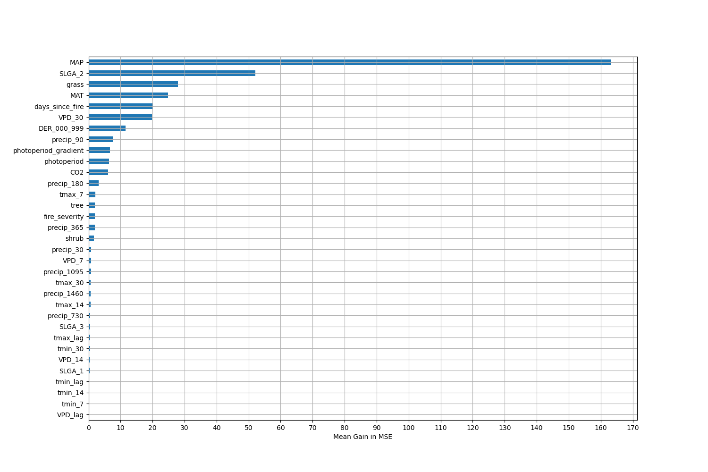

# Permutation Importance by Precip

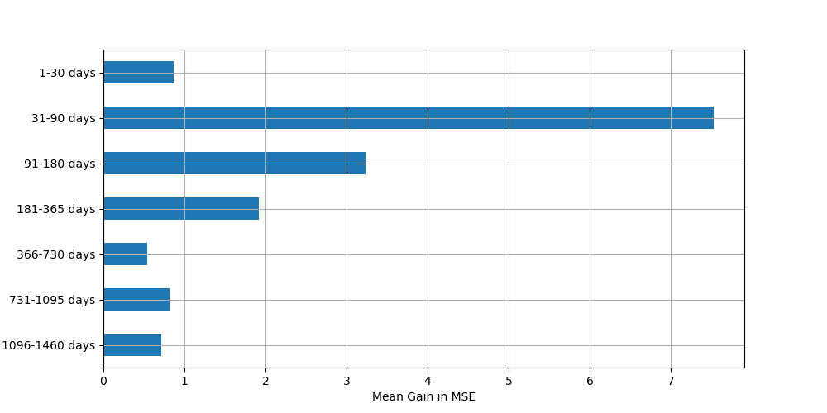

# ALE Importance

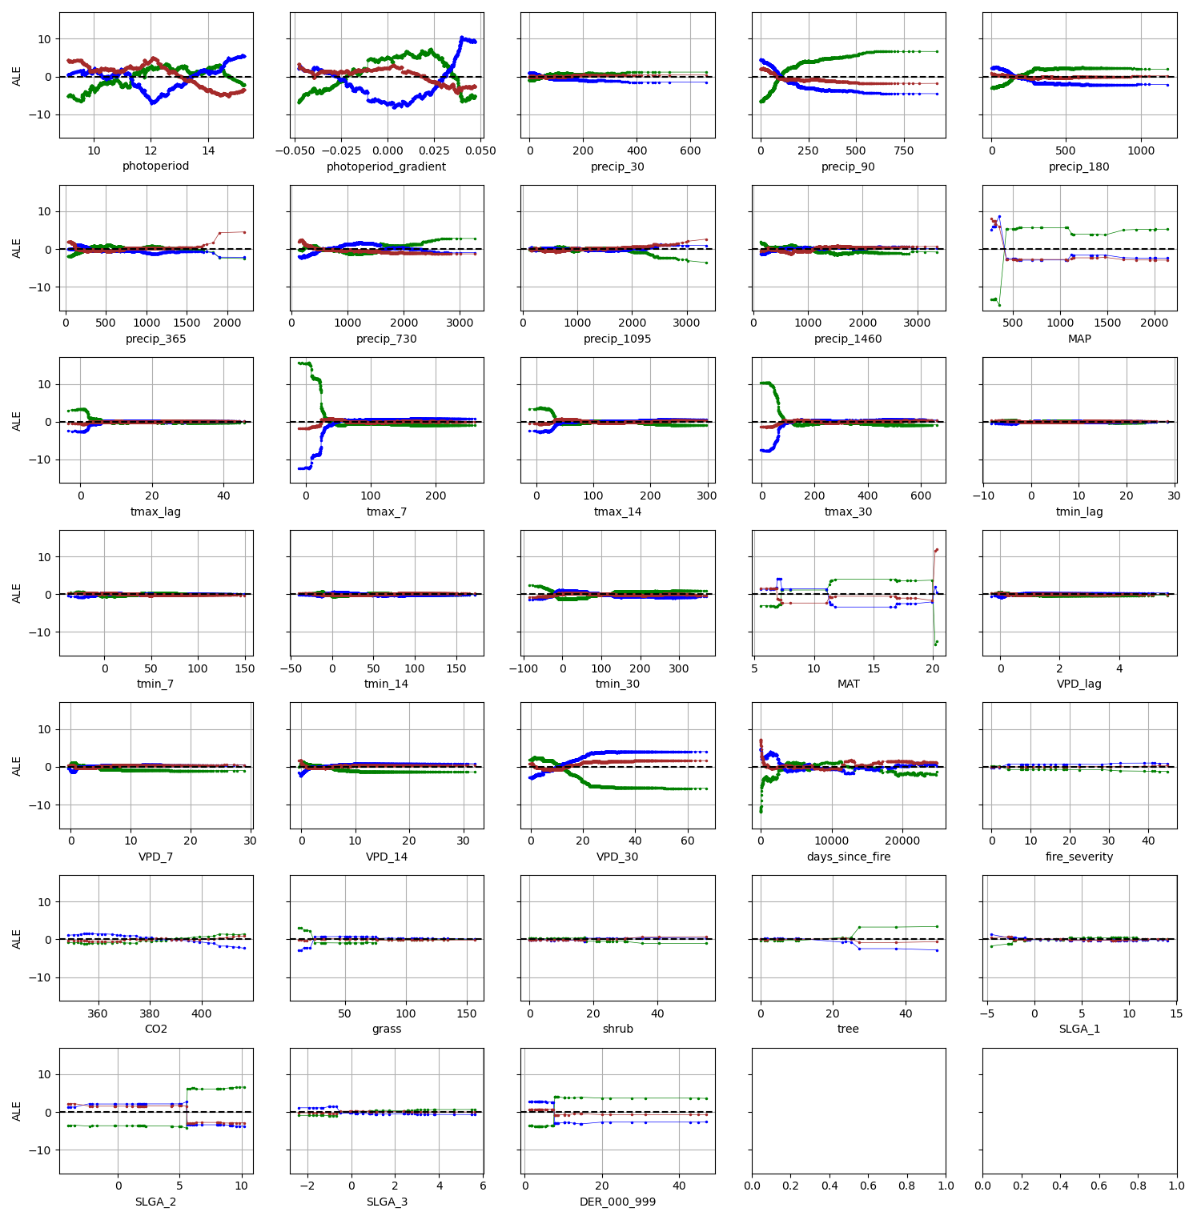

# QDASEQ0002

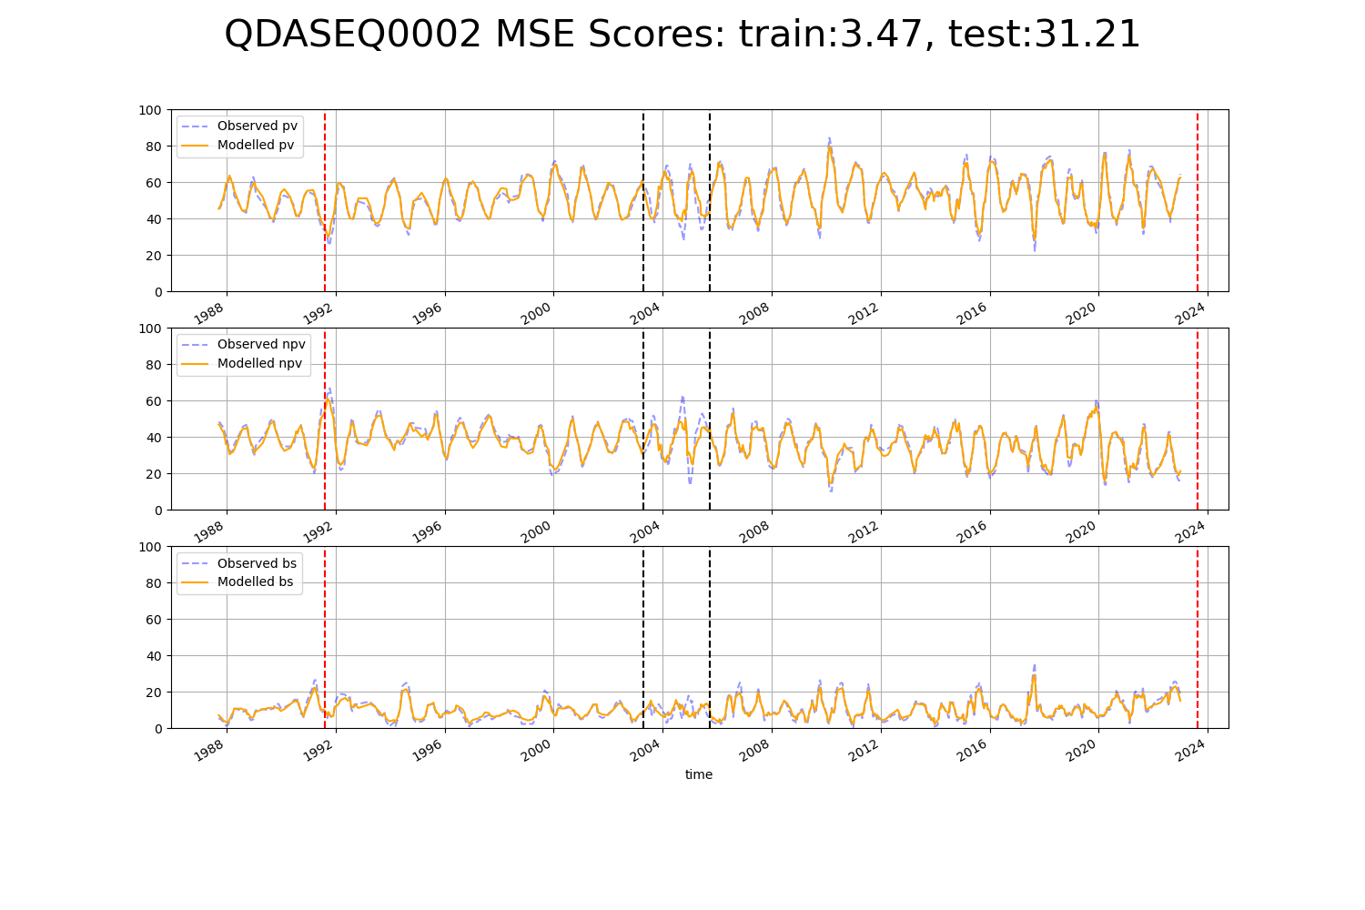

# SAAEYB0029

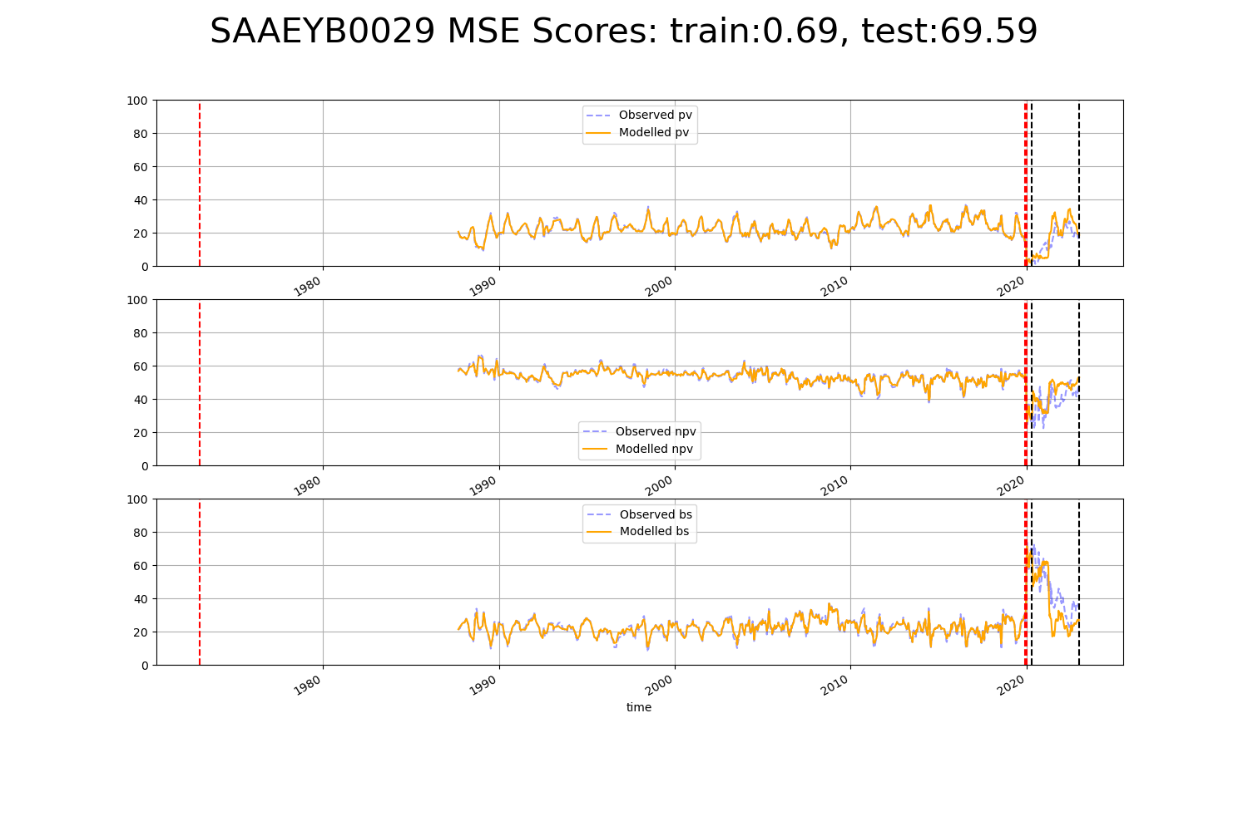

# SAAEYB0032

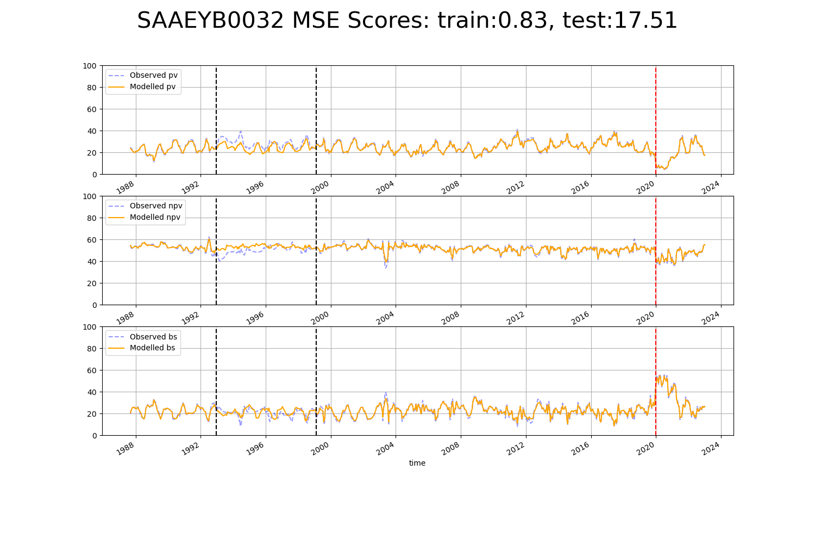

# SAAMDD0007

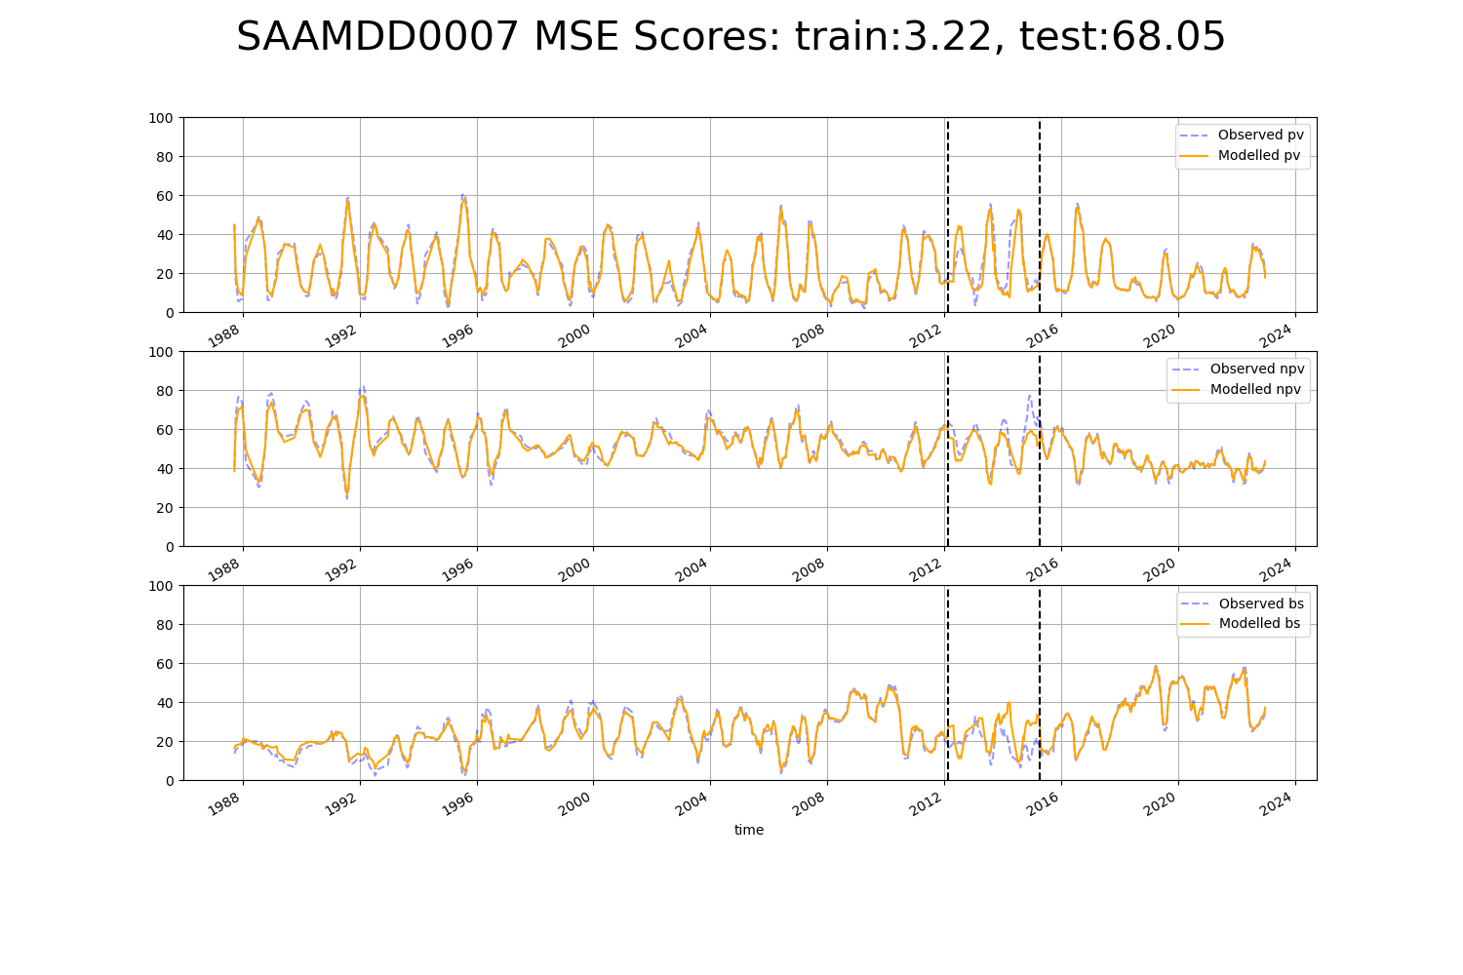

# SAAMDD0009

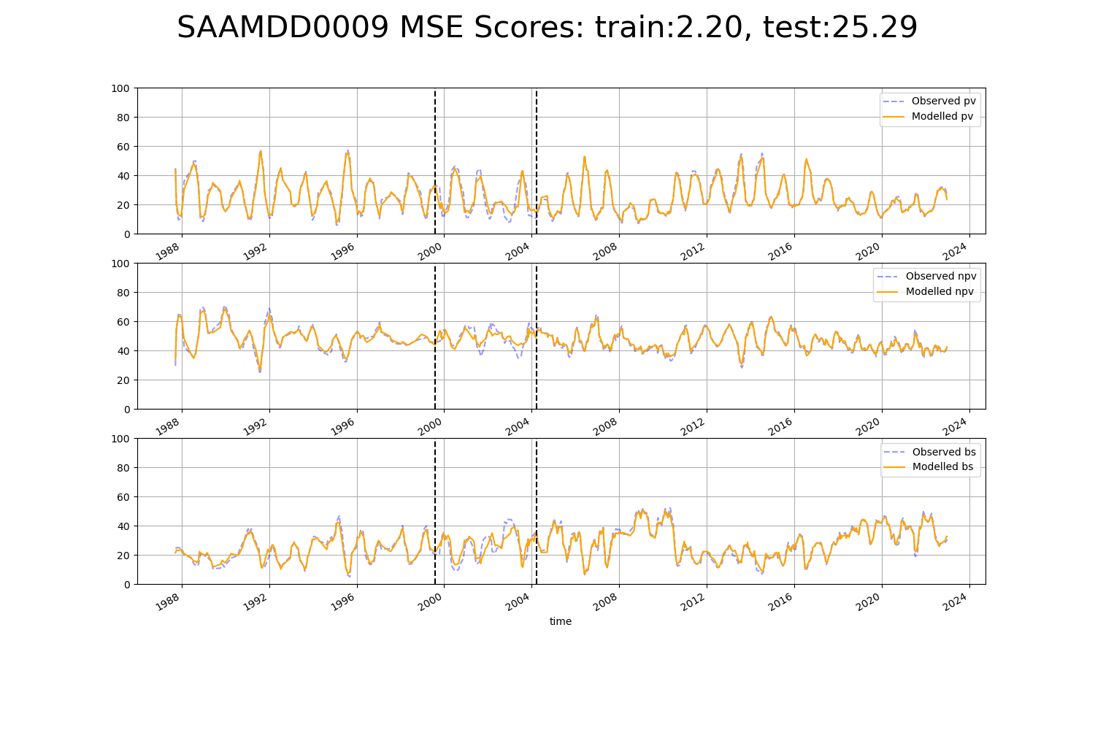

# SATEYB0001

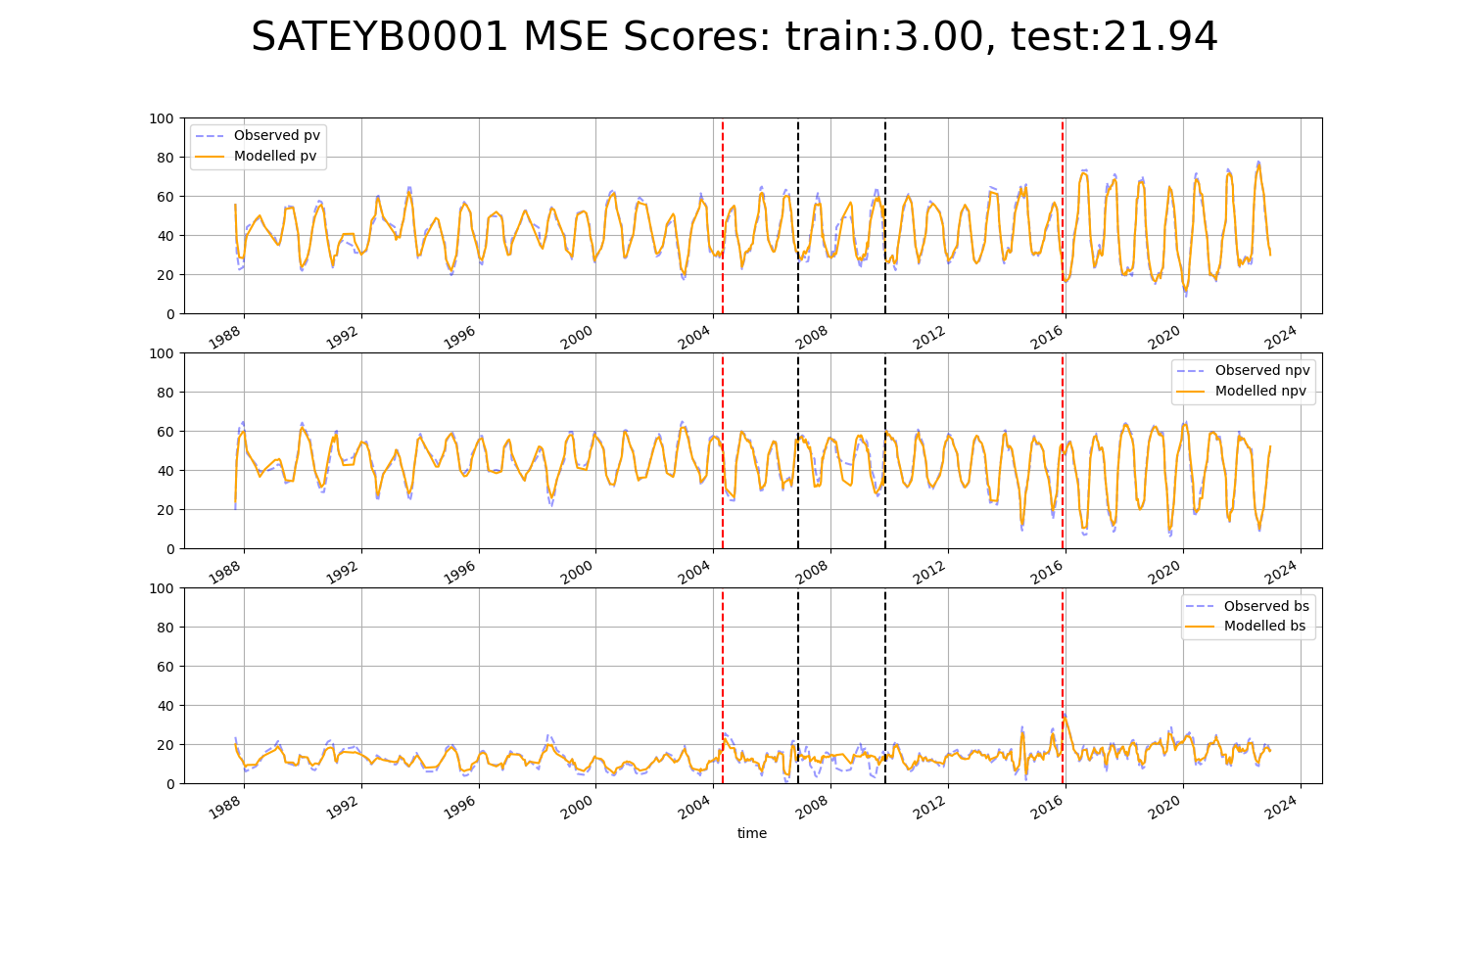

# SATFLB0028

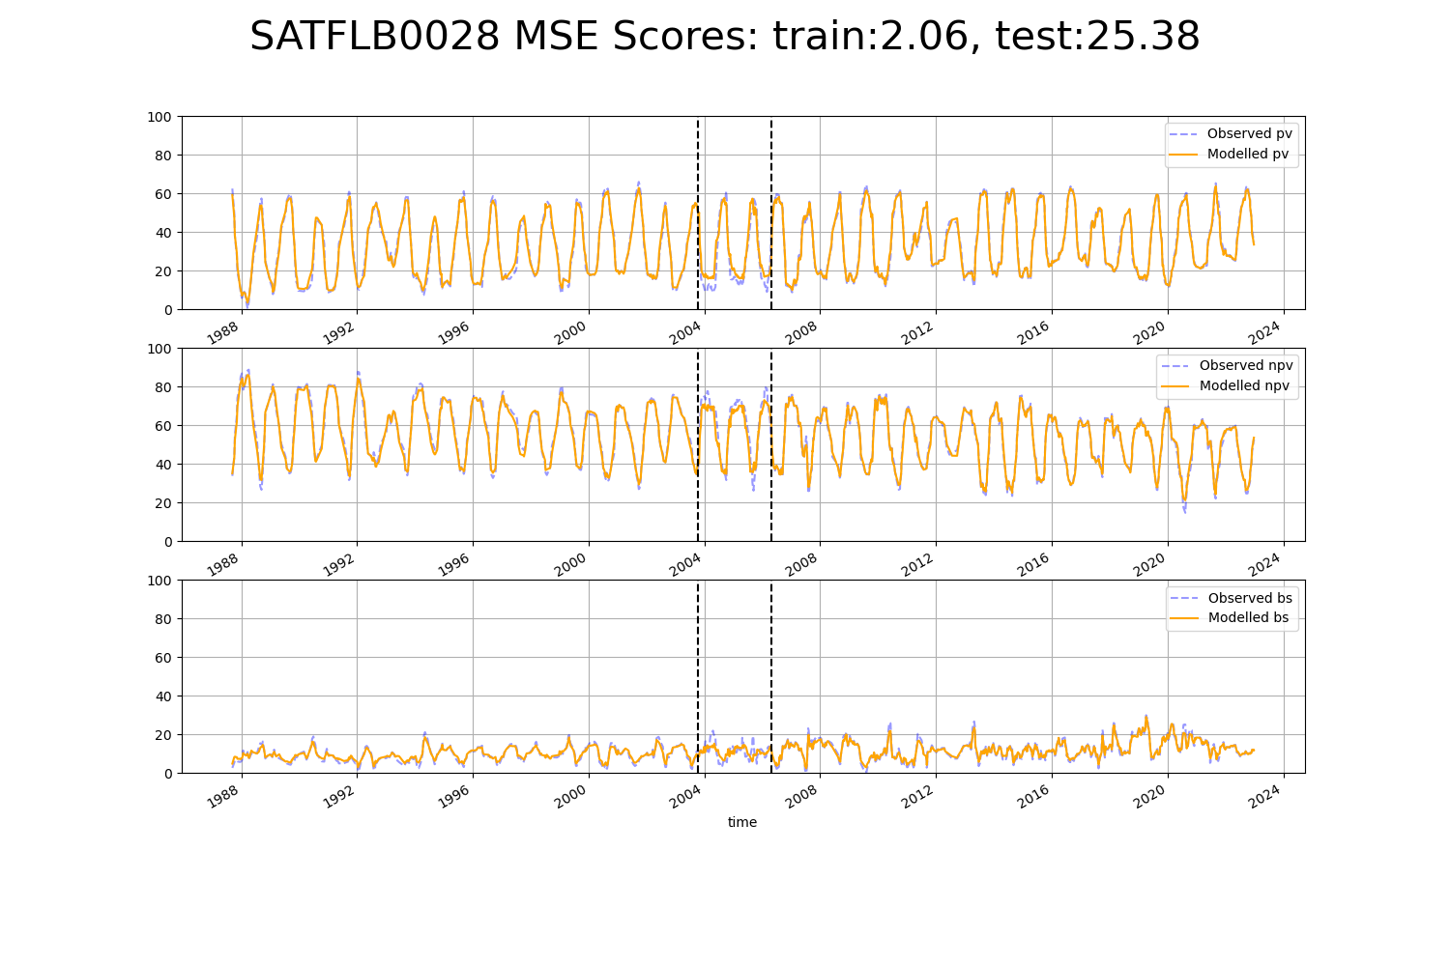

# TCABEL0001

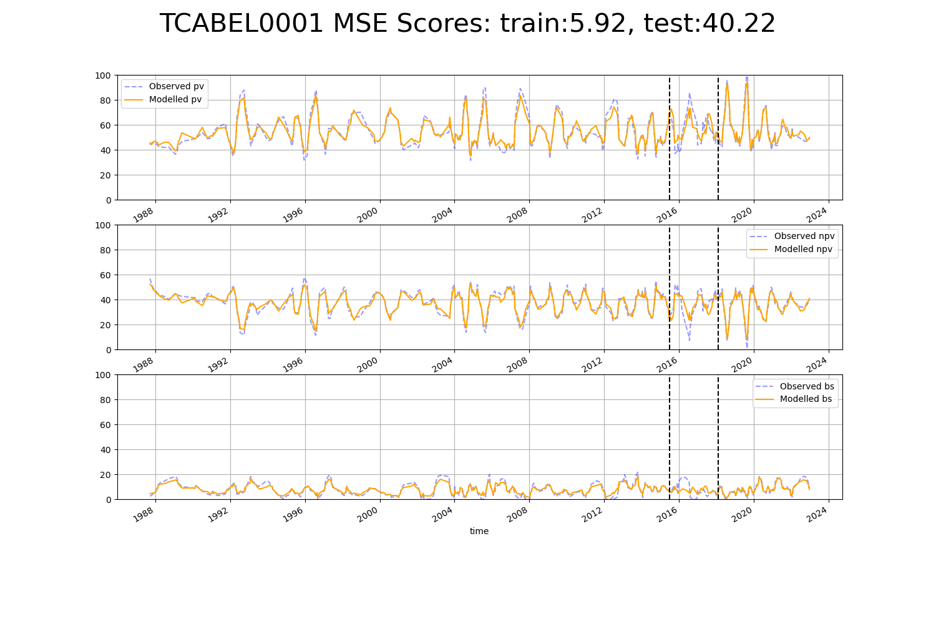

# TCABEL0003

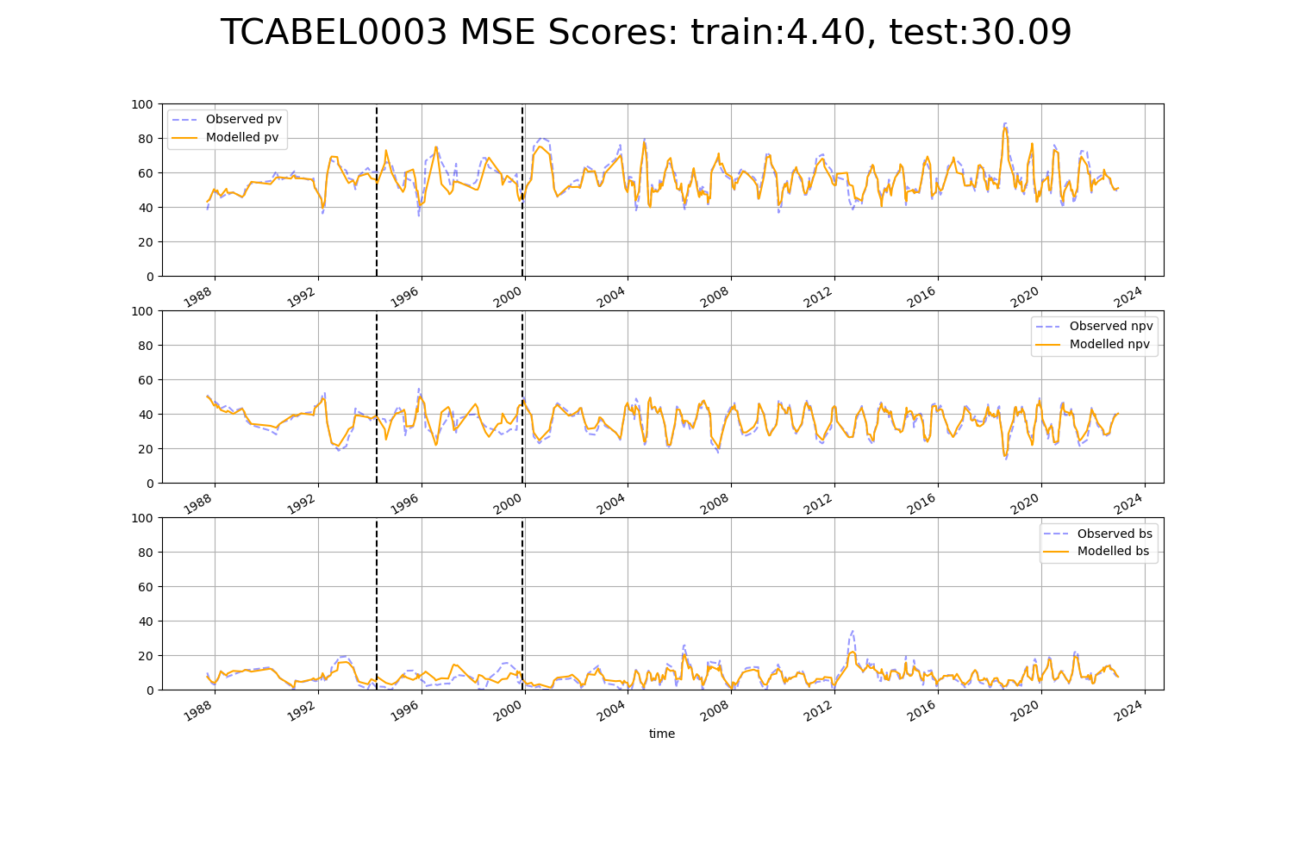

# TCATCH0002

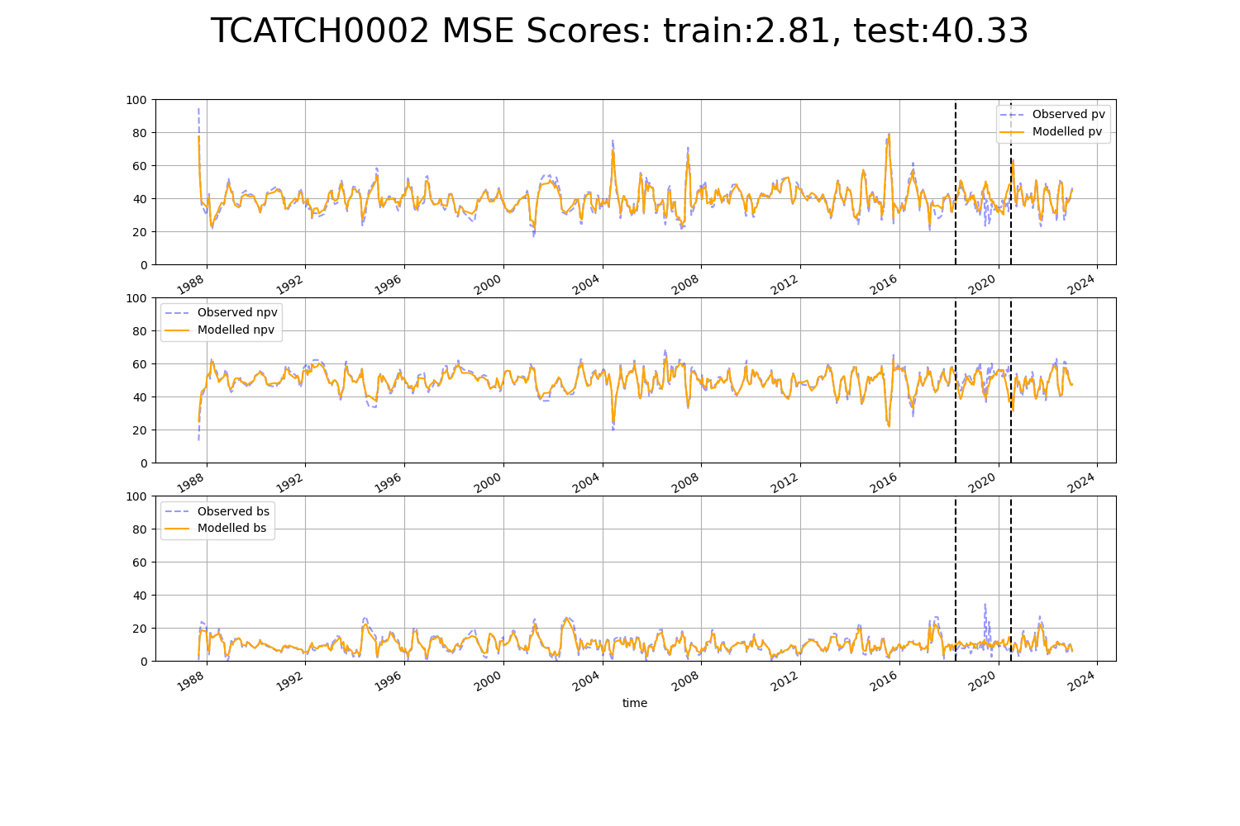

# TCATCH0003

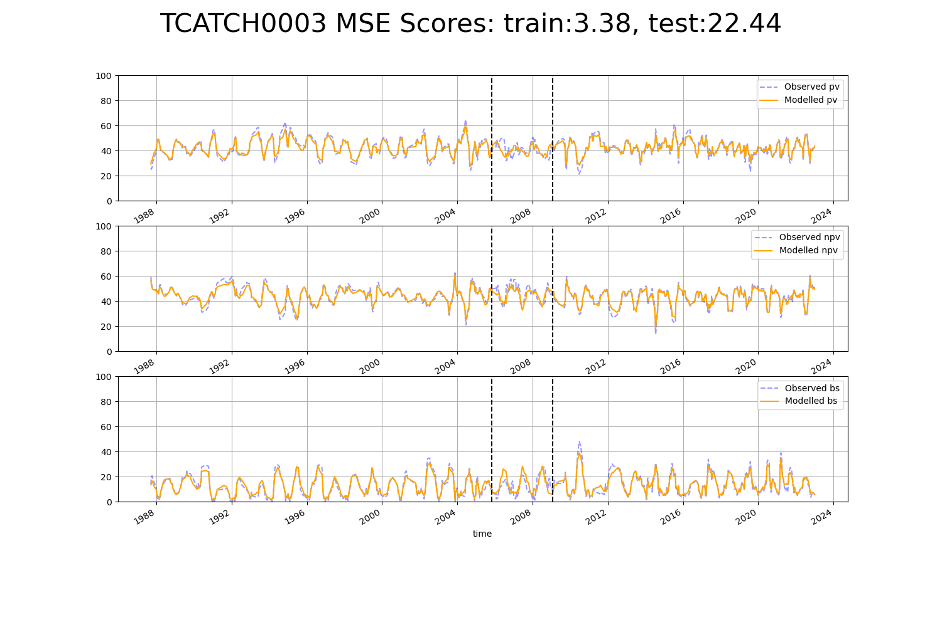

# TCATCH0005

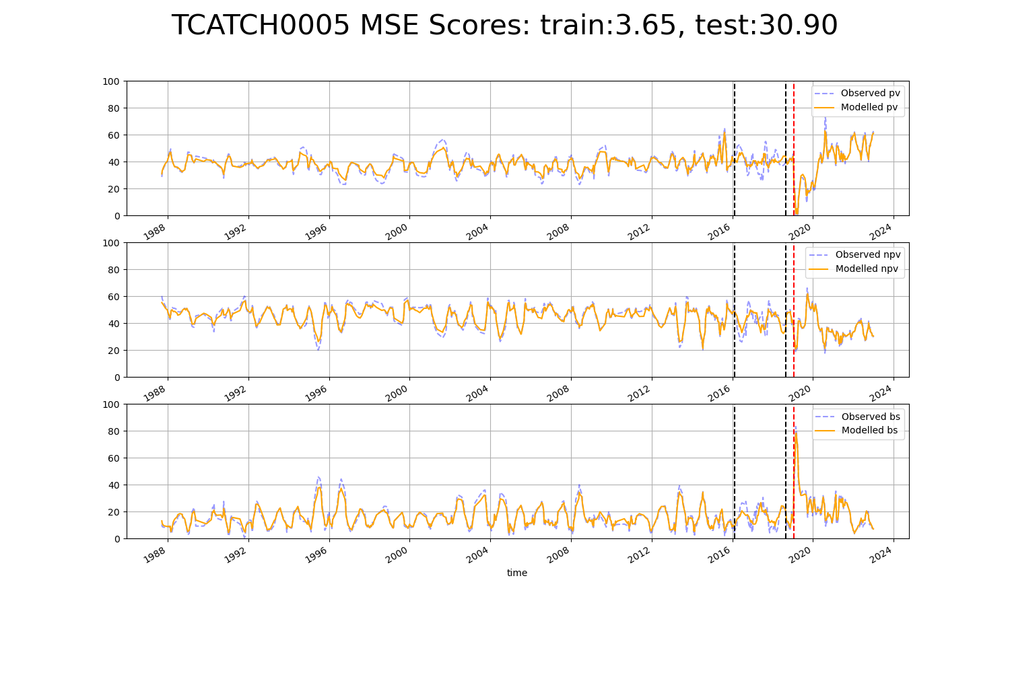

# TCATCH0006

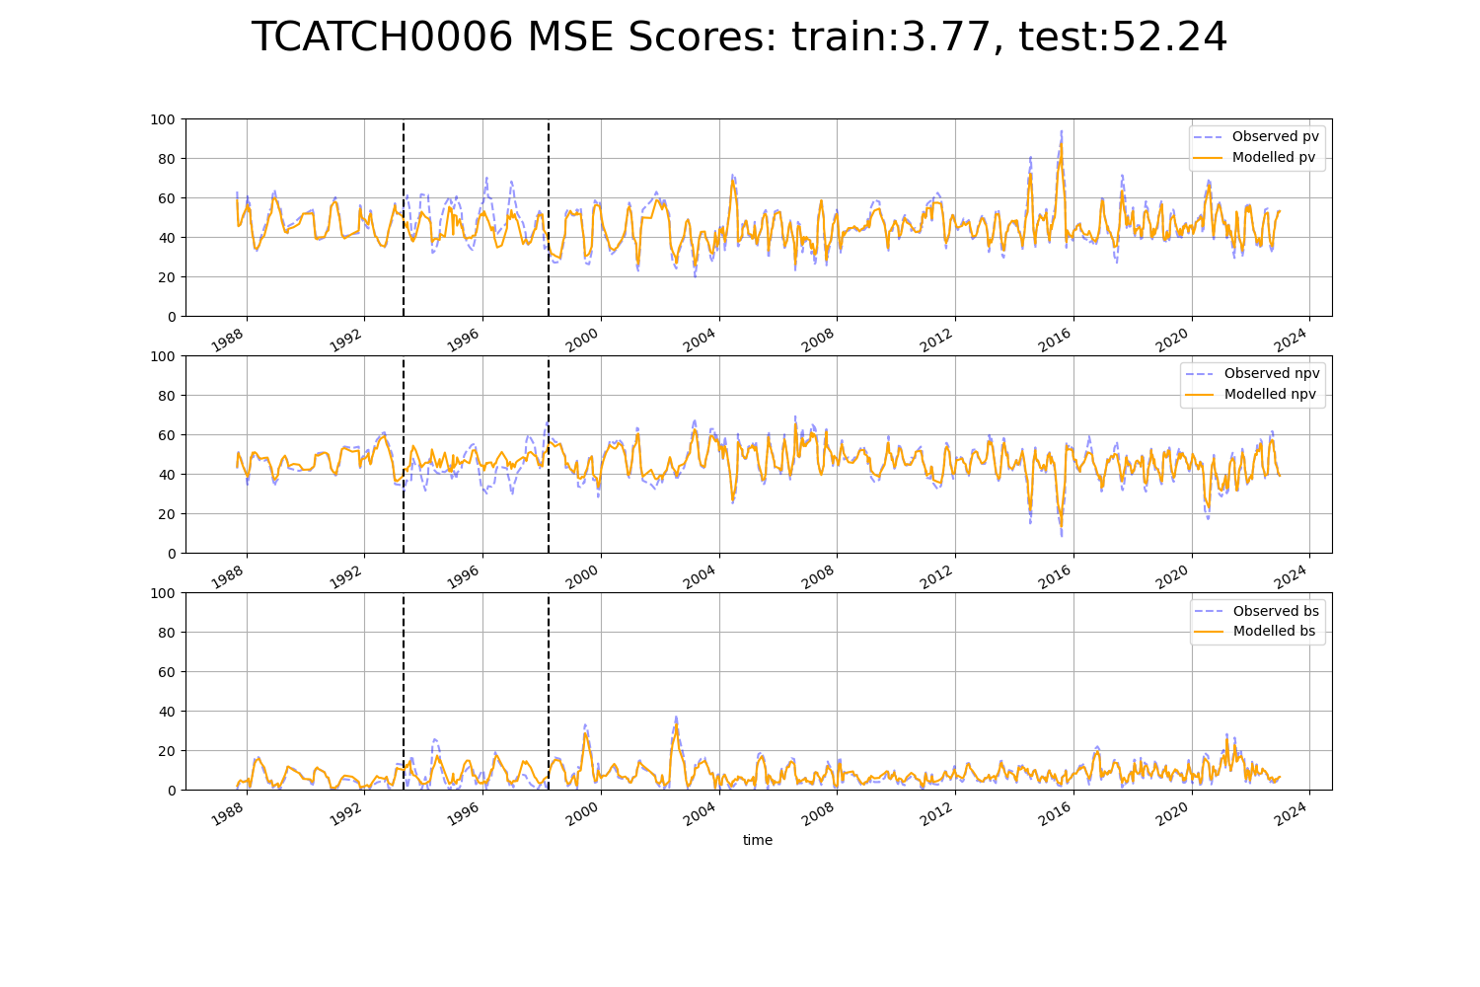

# TCATCH0008

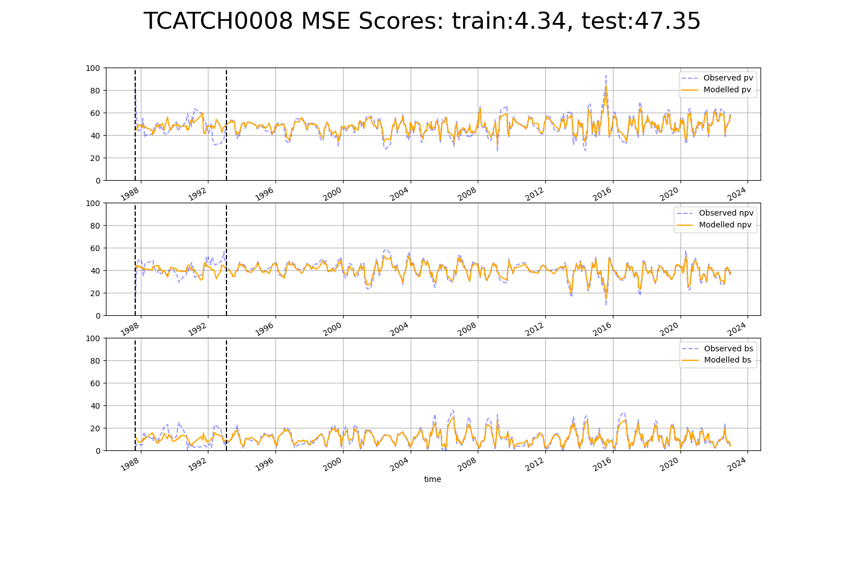

# TCATCH0009

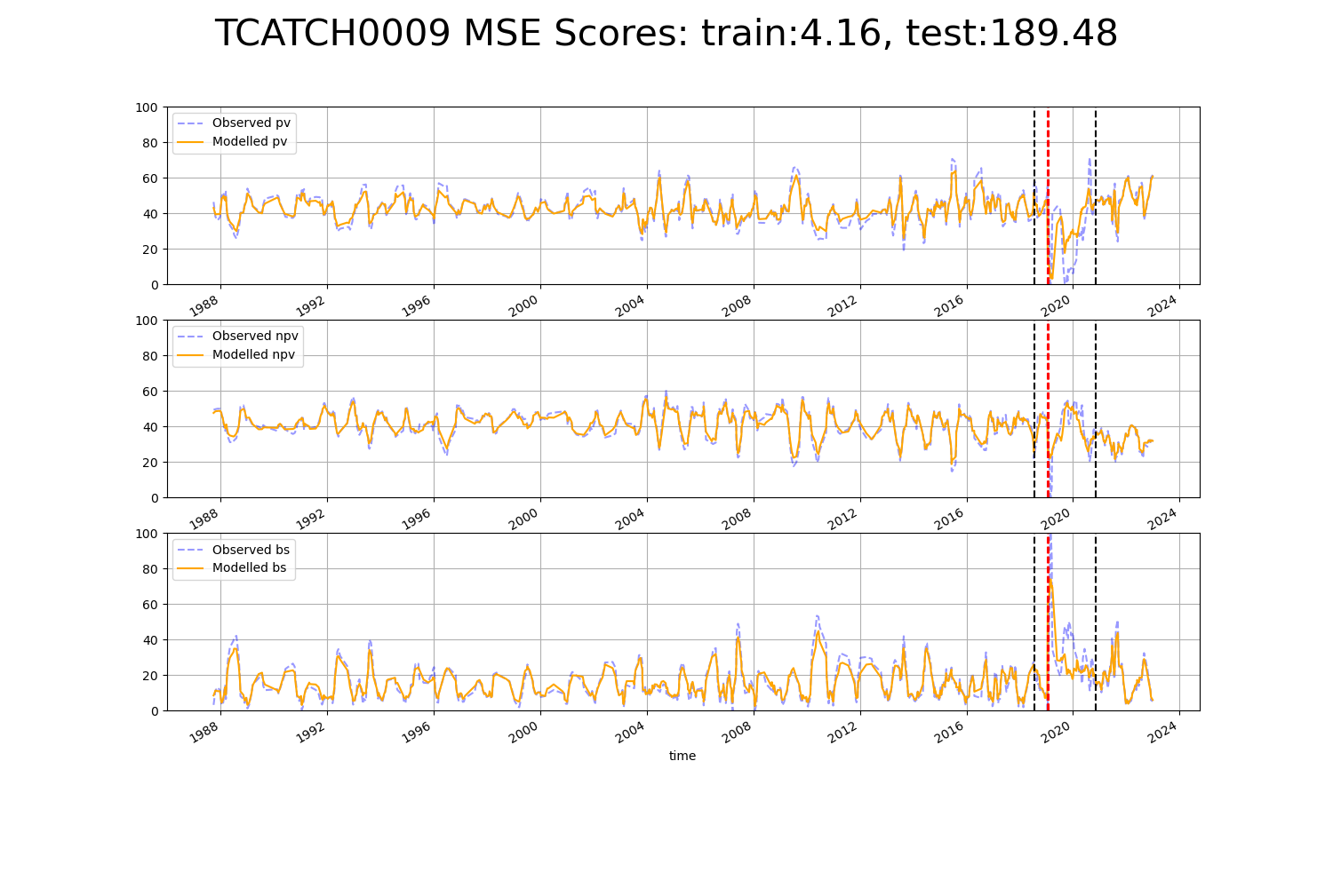

# TCATCH0010

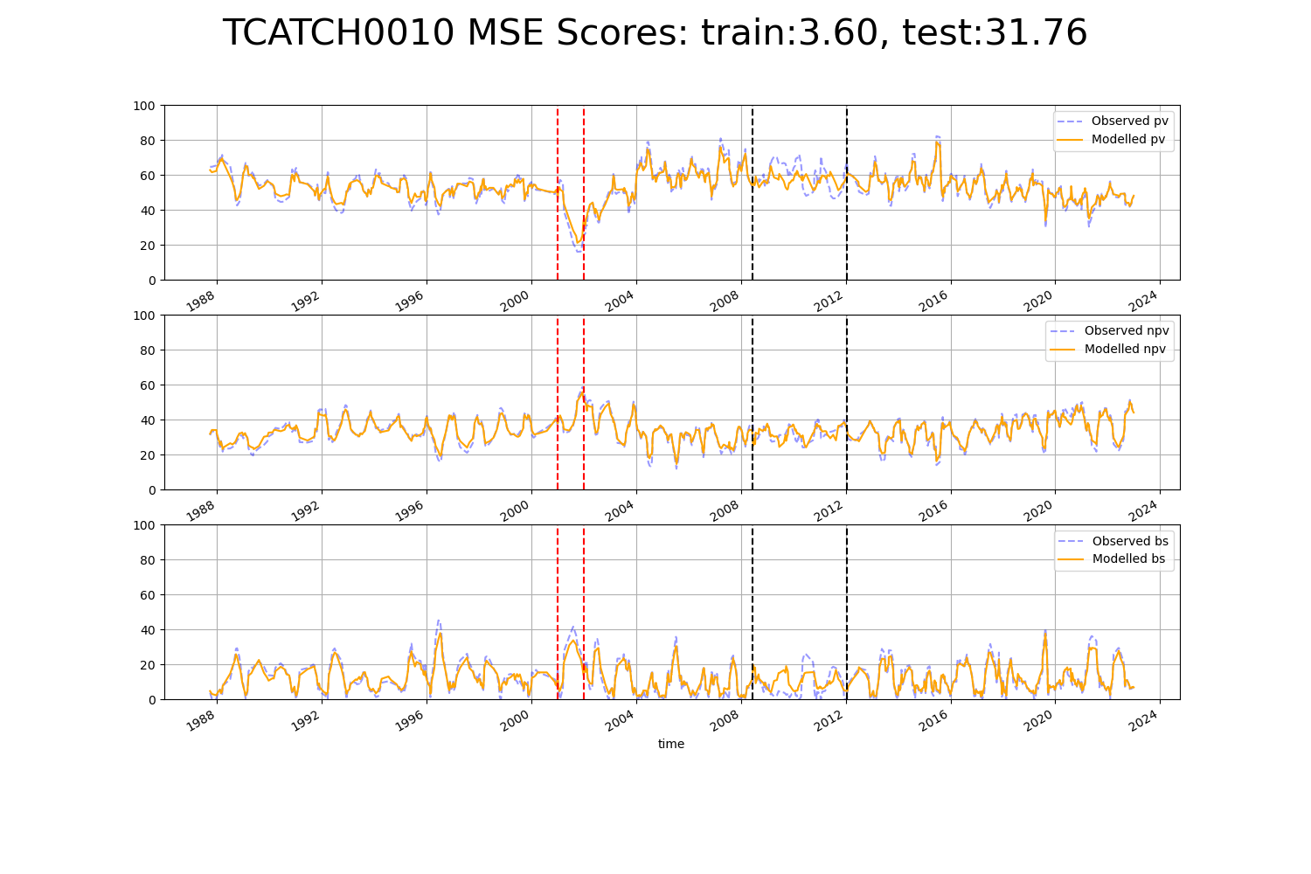

# TCATCH0012

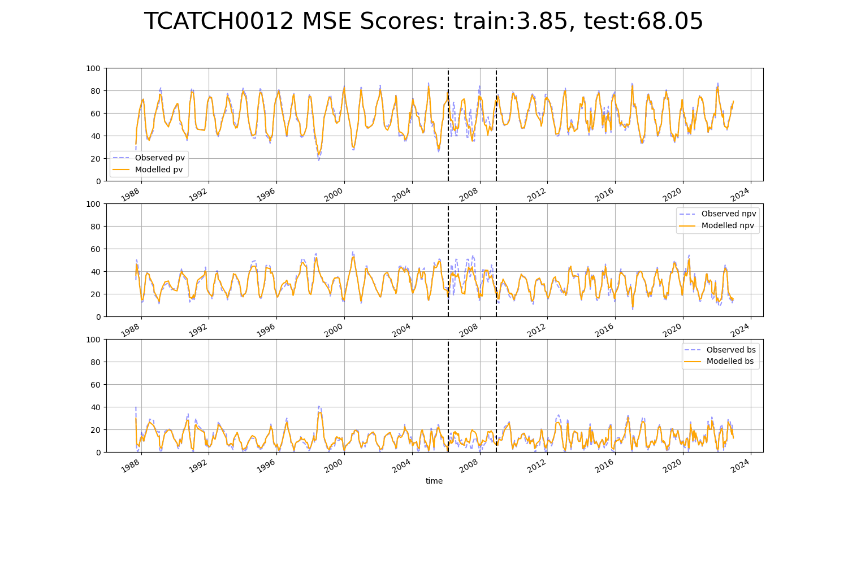

# TCATNM0001

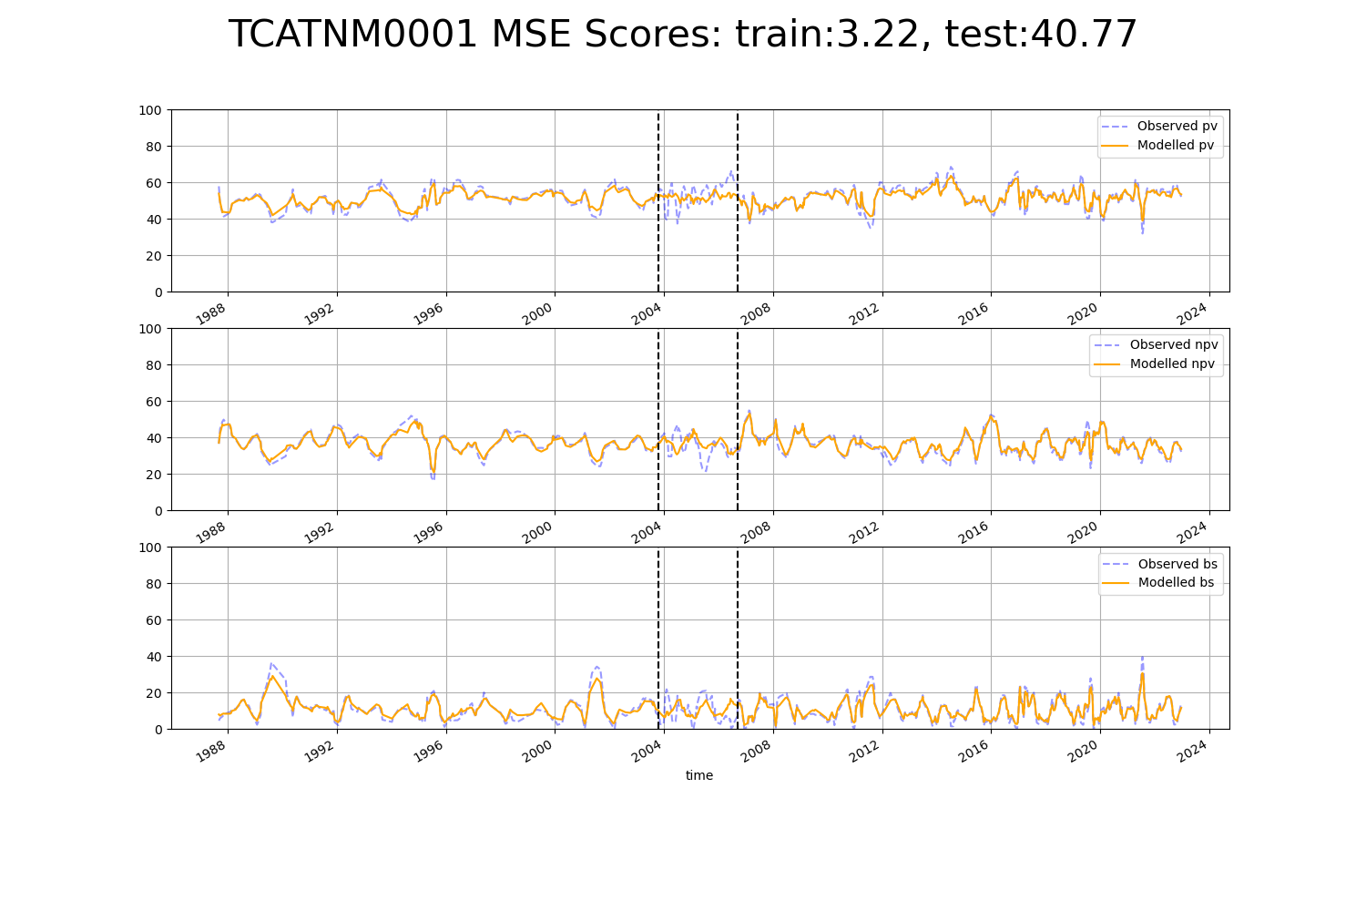

# TCATNM0002

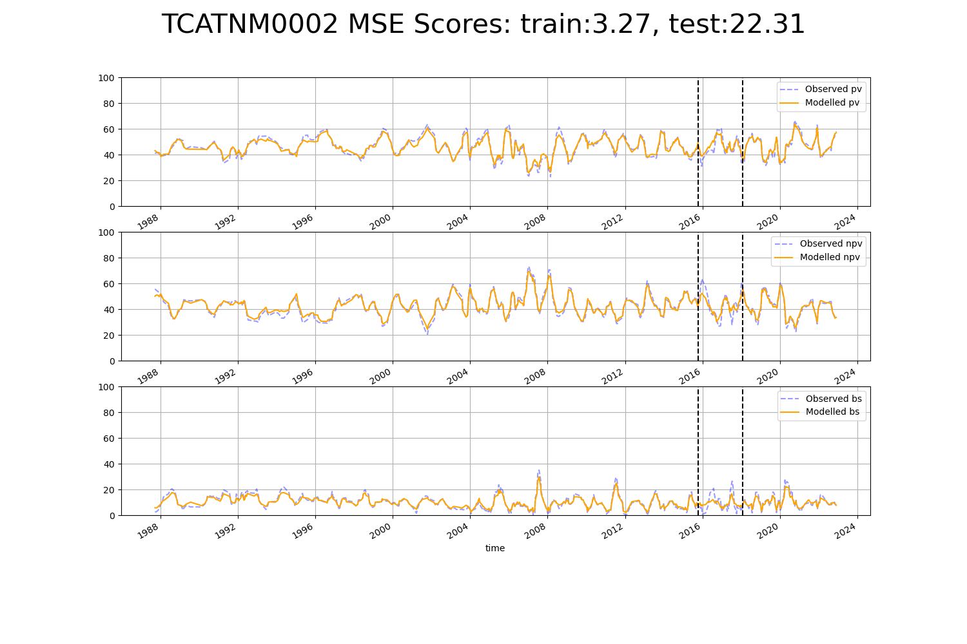

# TCATNM0003

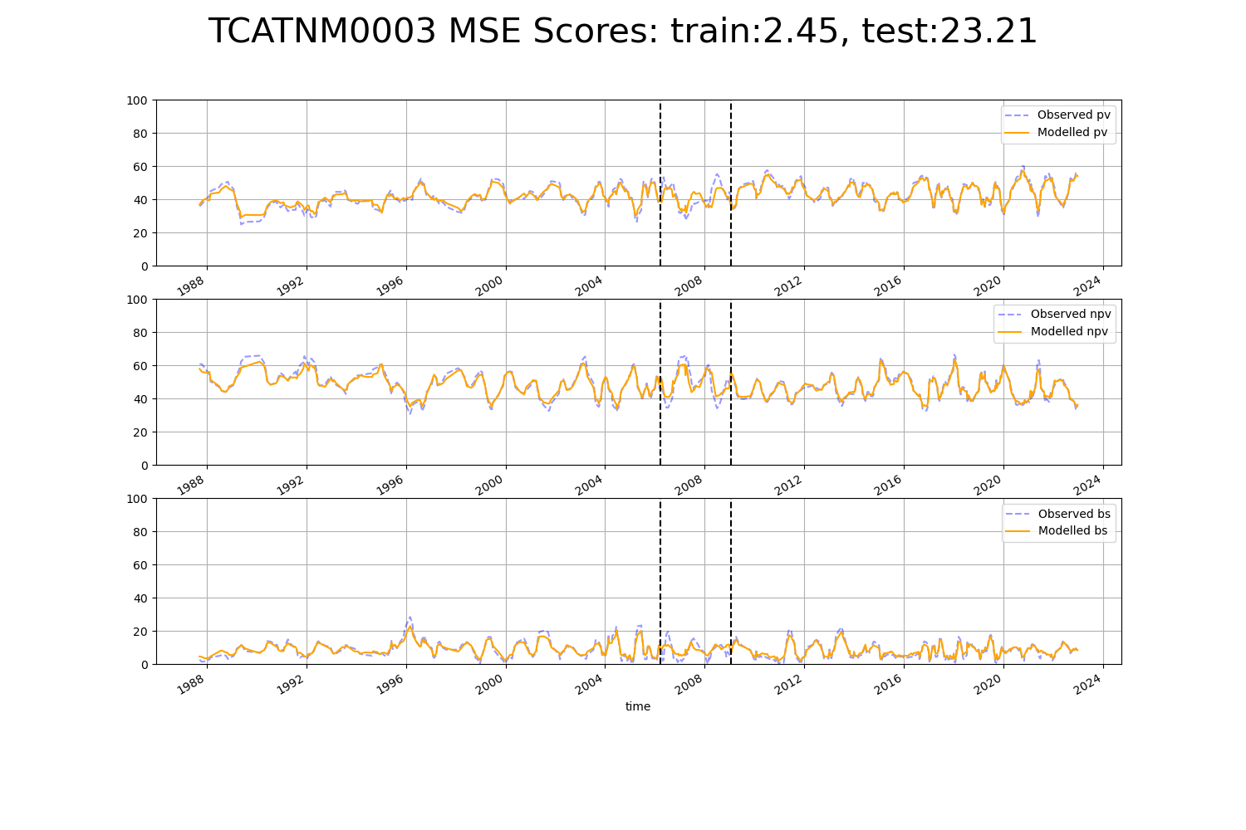

# TCATNM0004

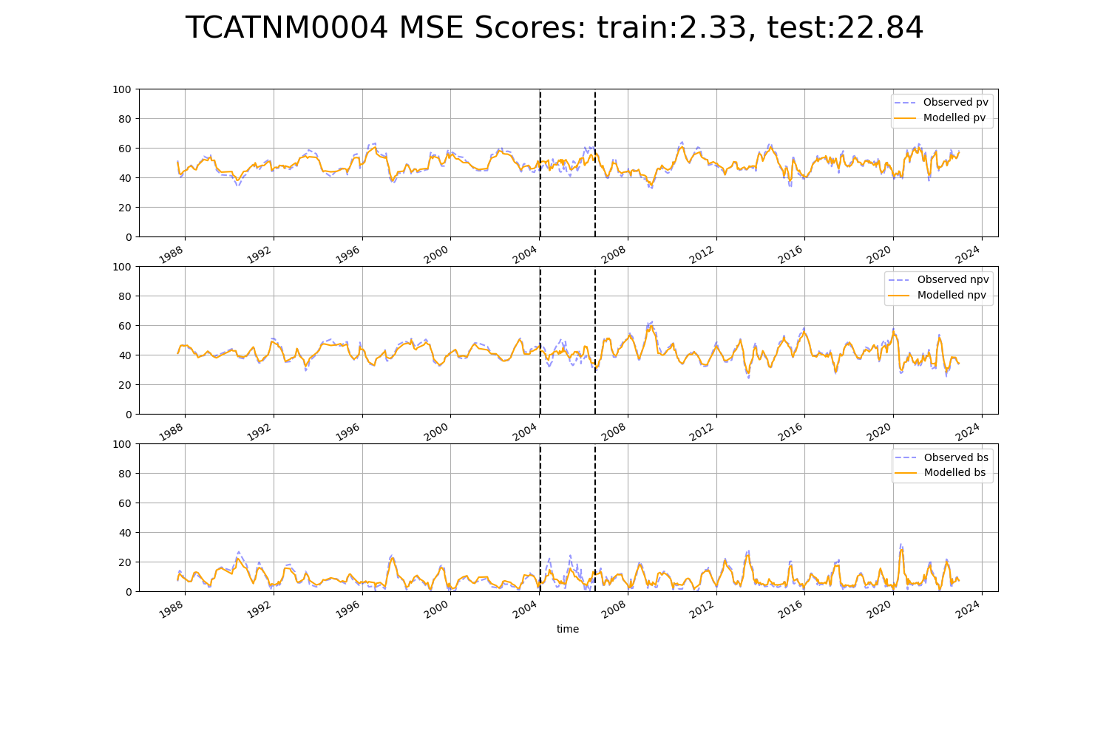

# TCATNM0005

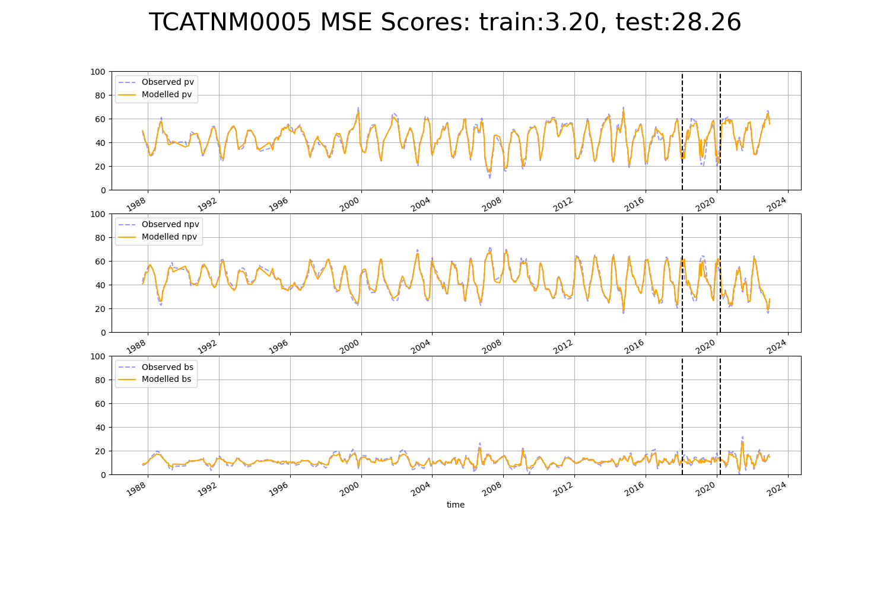

# TCATNM0006

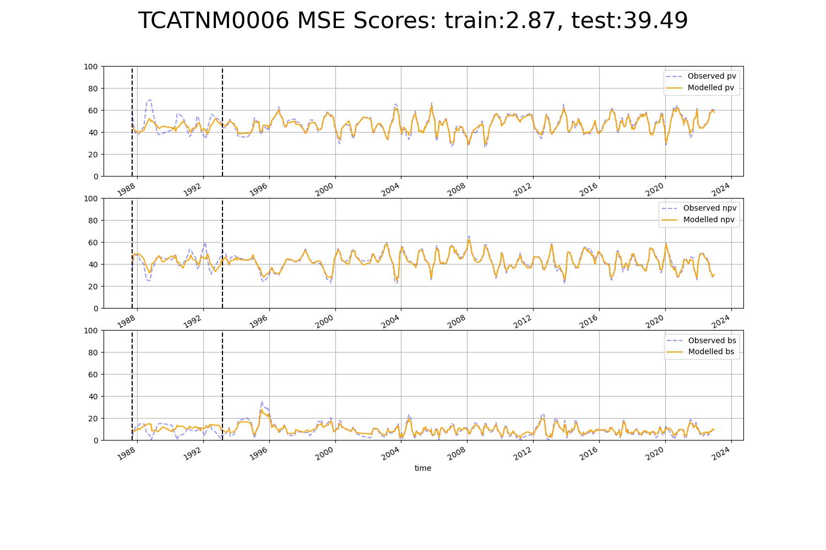

# VCAAUA0001

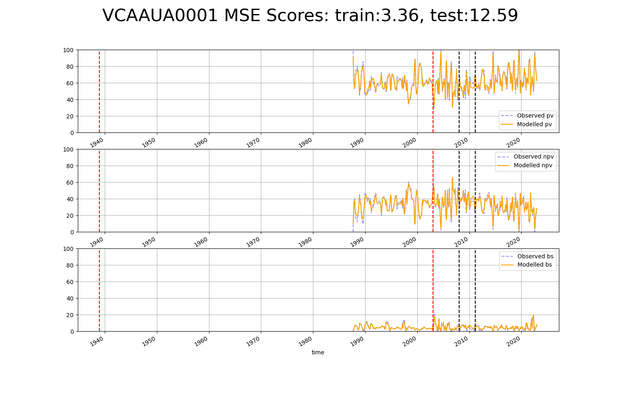

# VCAAUA0002

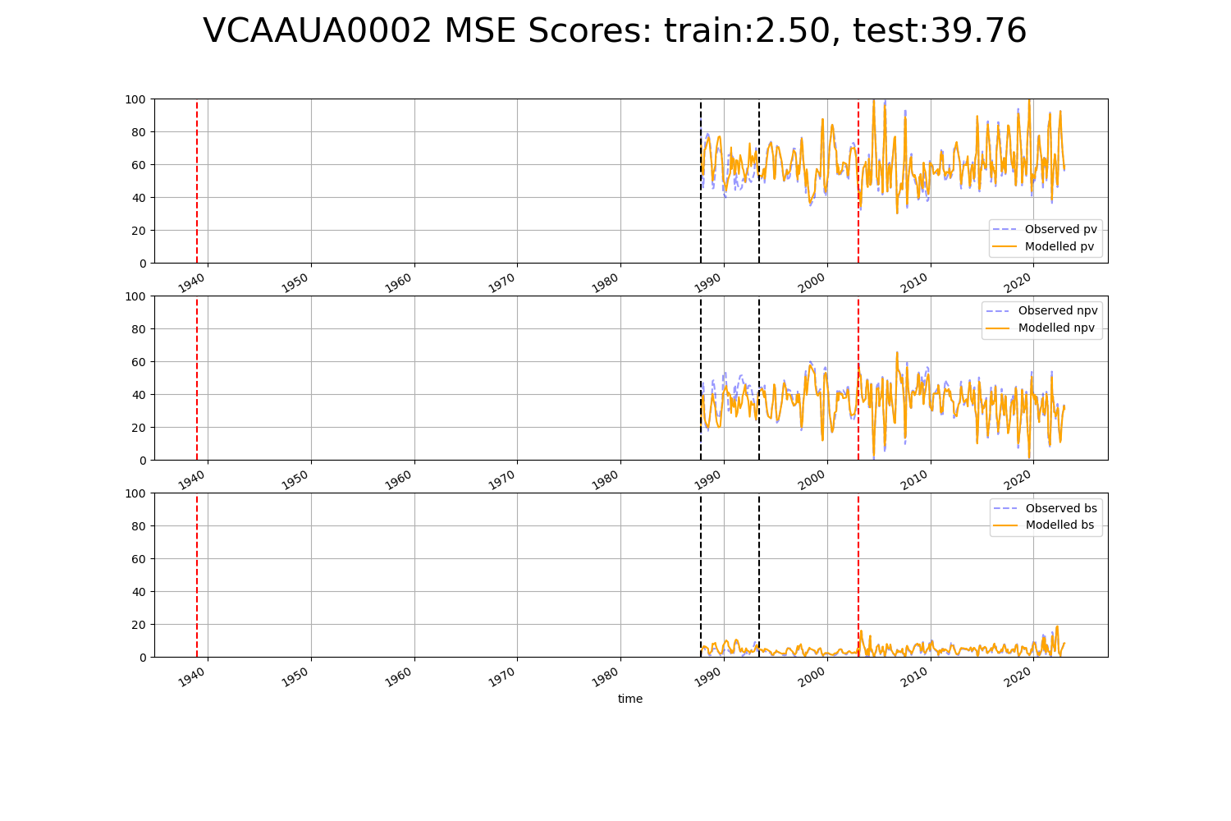

# VCAAUA0003

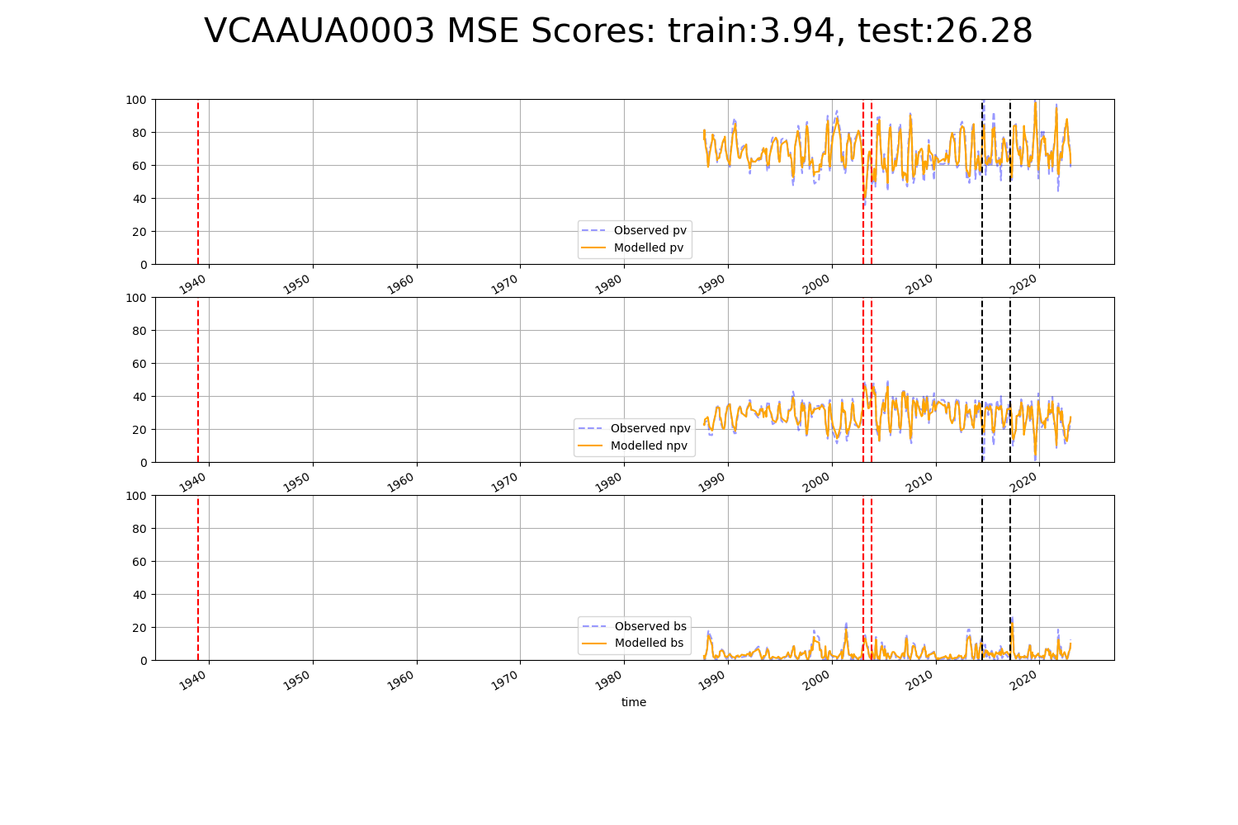

# VCAAUA0005

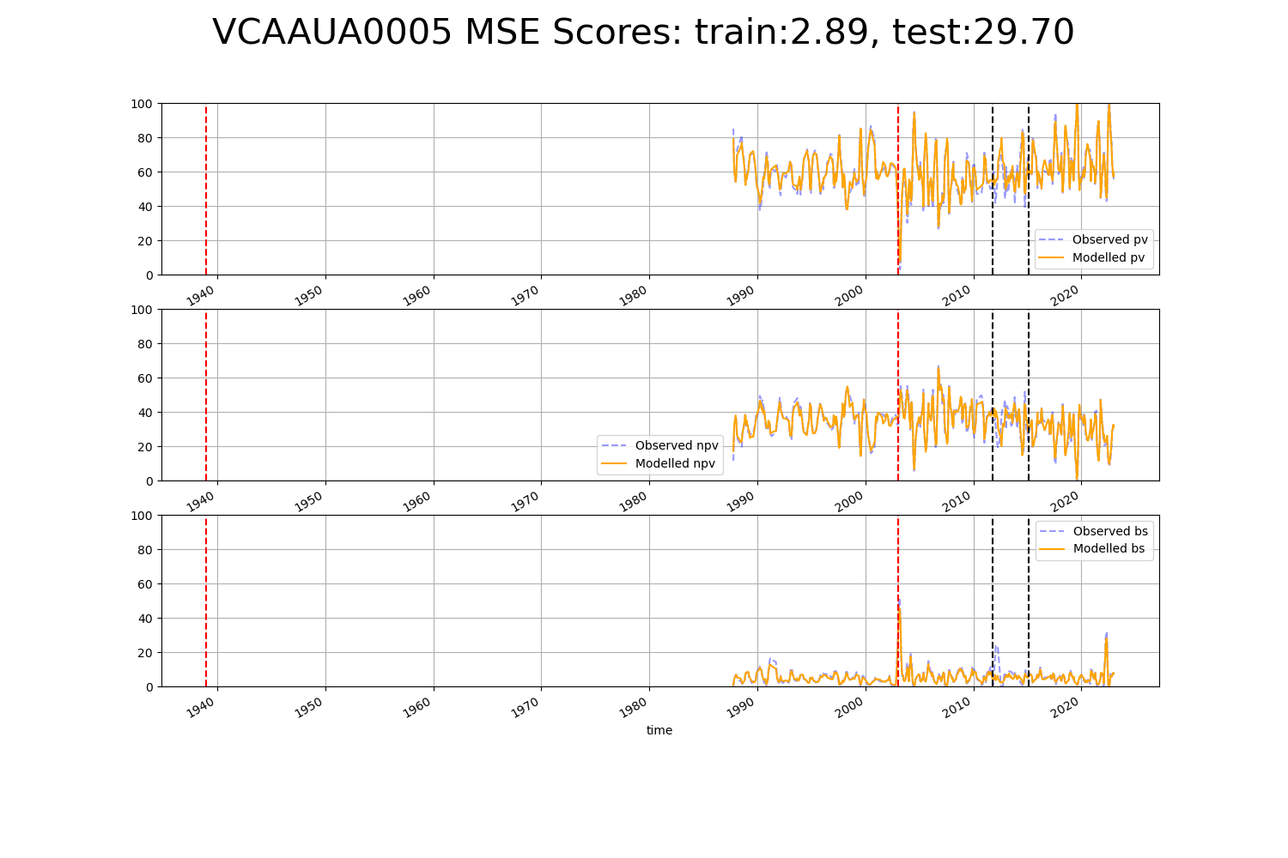

# VCAAUA0006

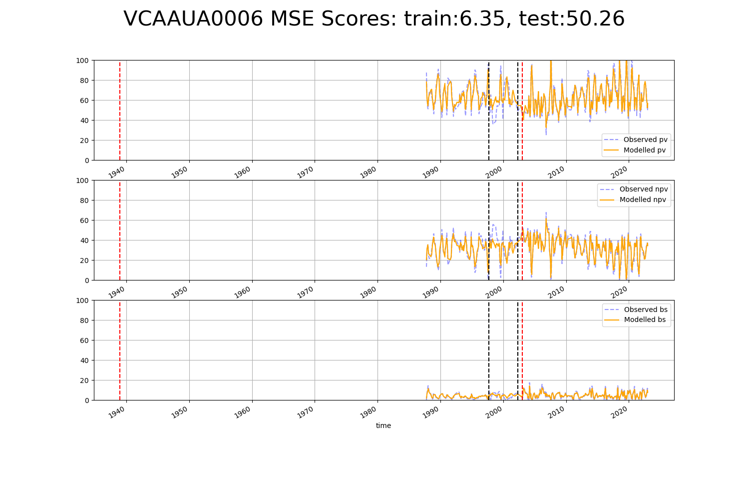

# VCAAUA0007

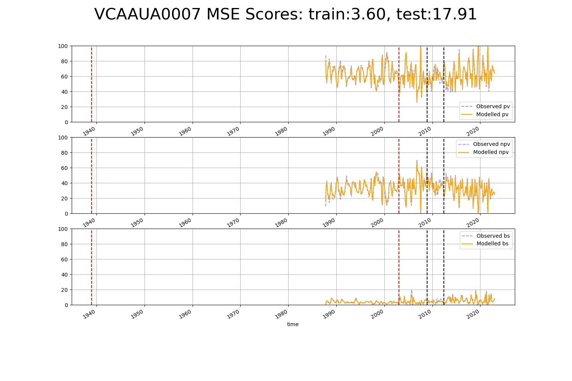

# VCAAUA0010

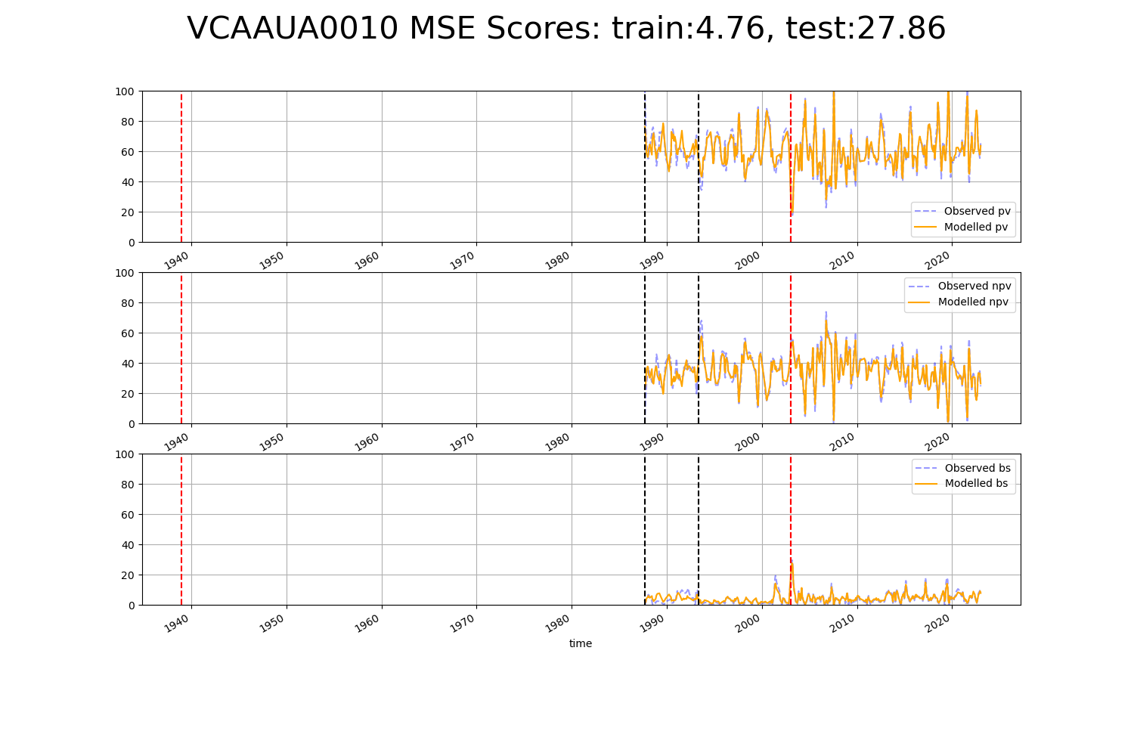

# VCAAUA0011

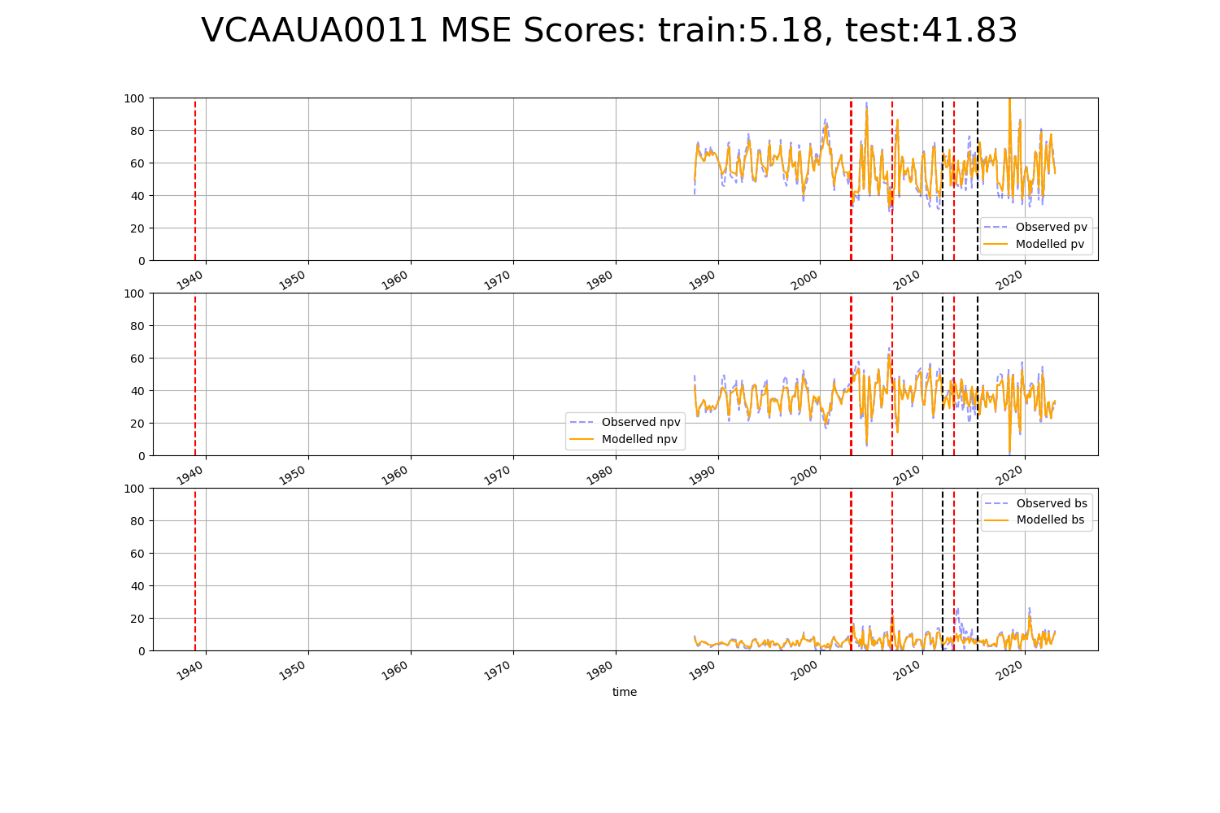

# VCAAUA0012

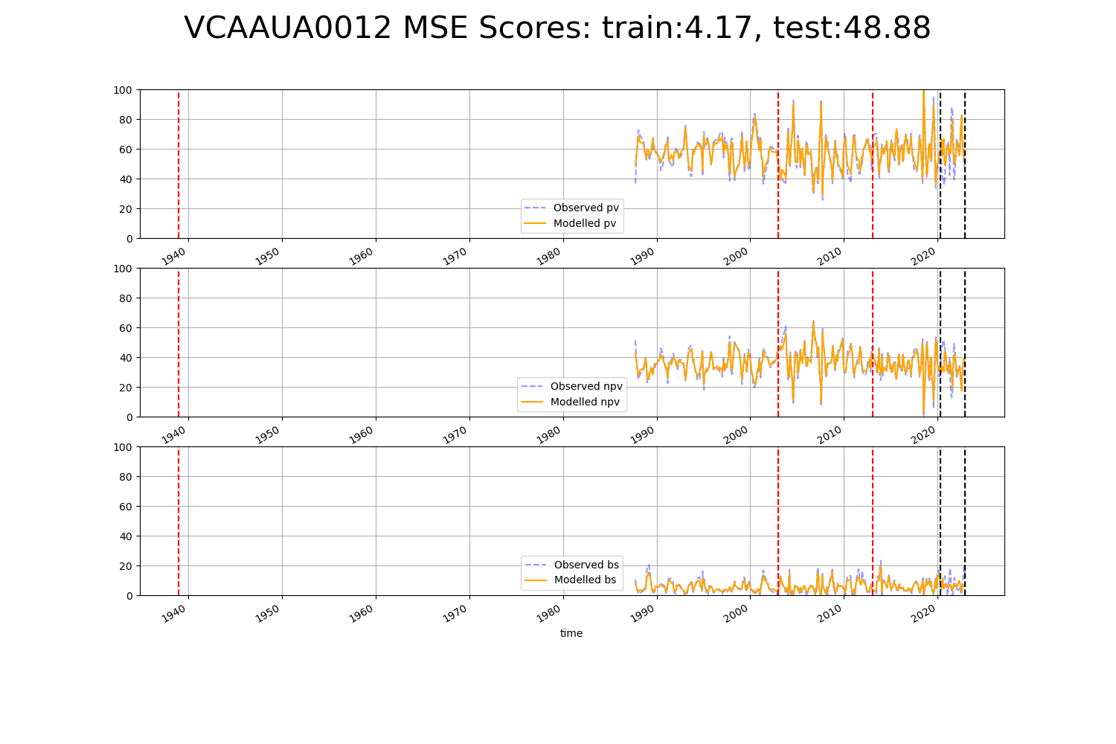

# VCAAUA0013

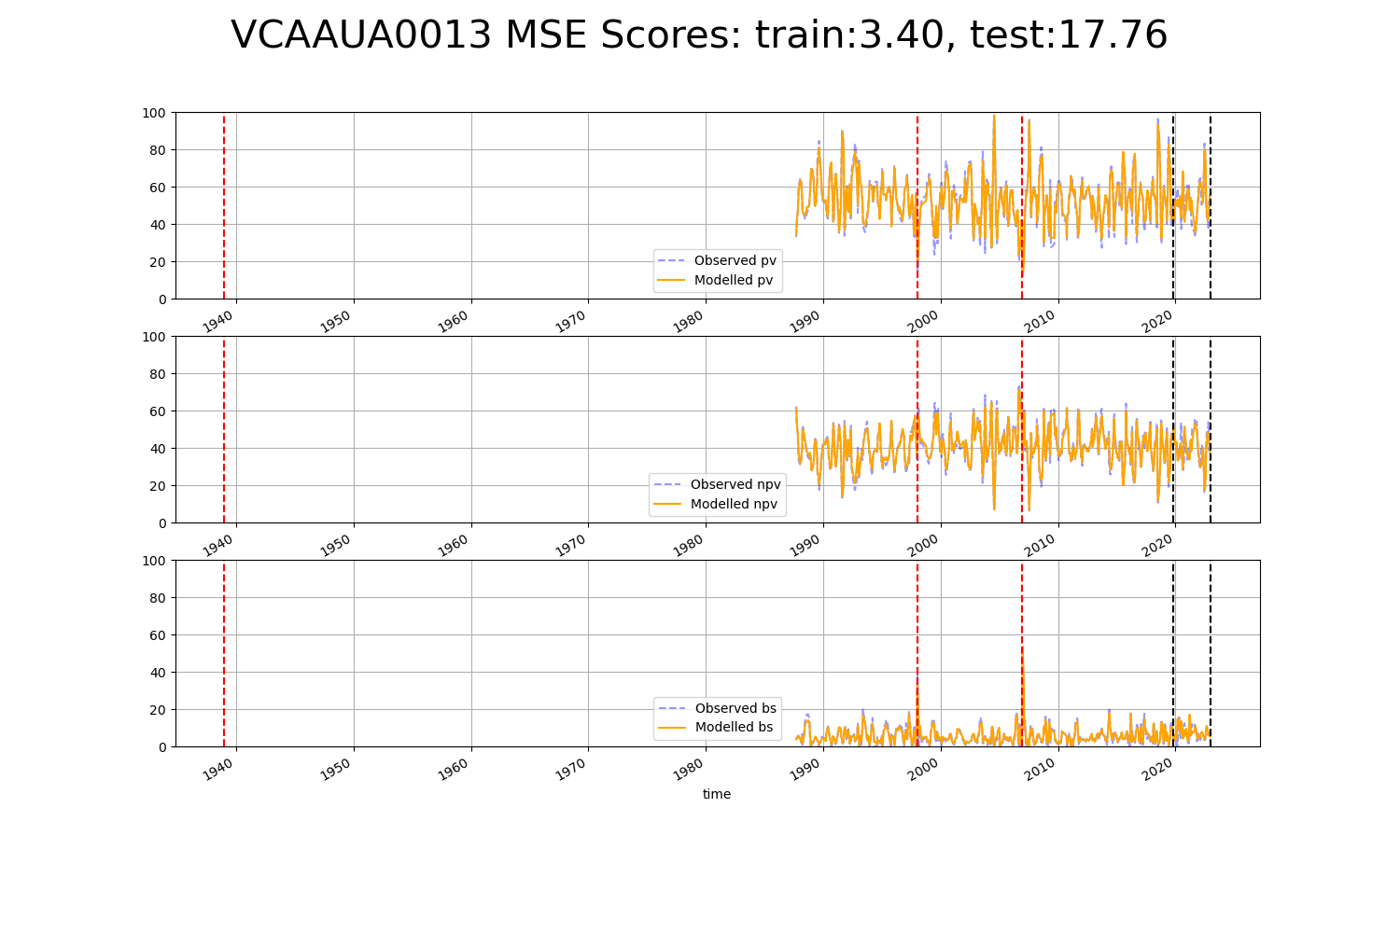

# VCAAUA0014

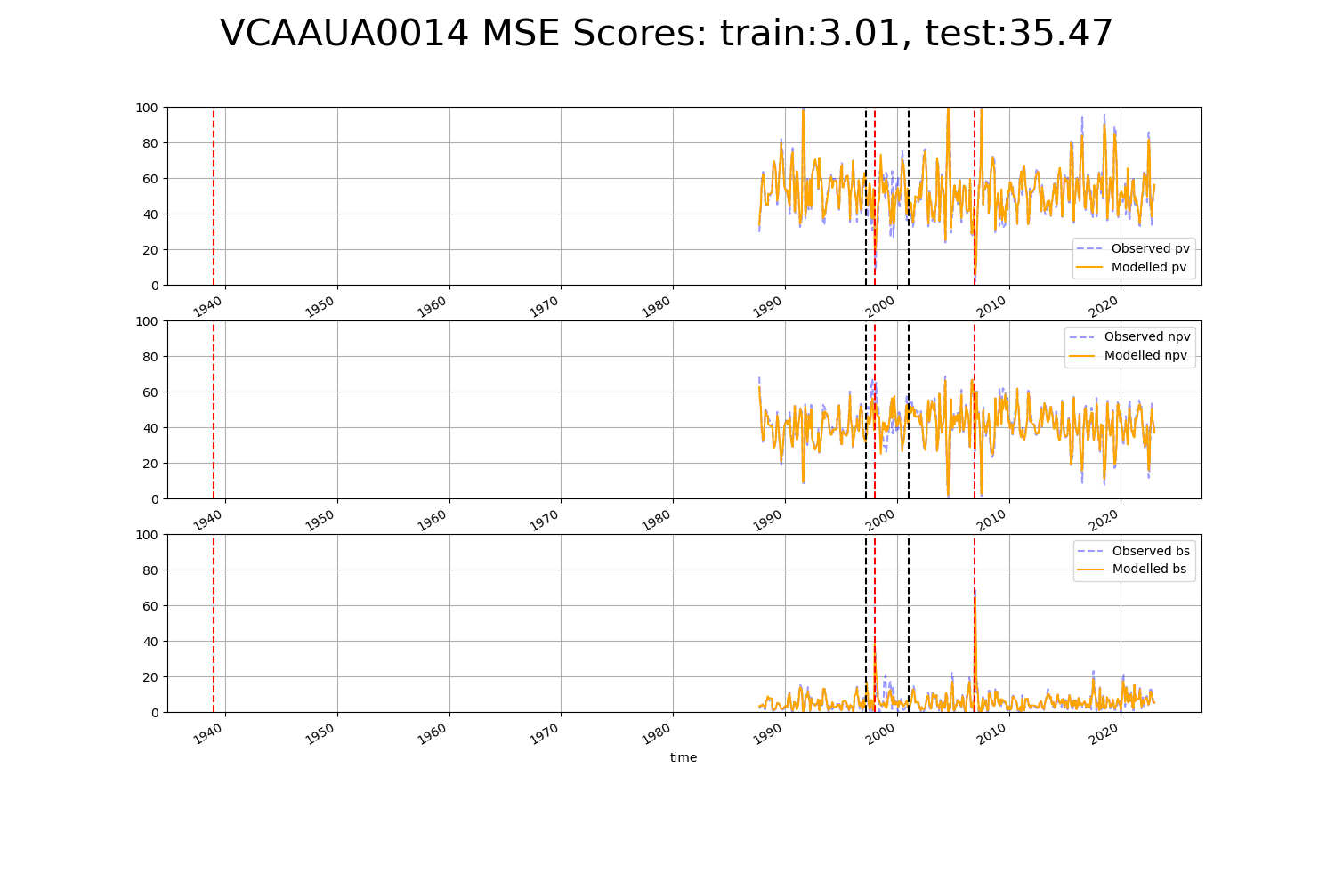

# VCAAUA0015

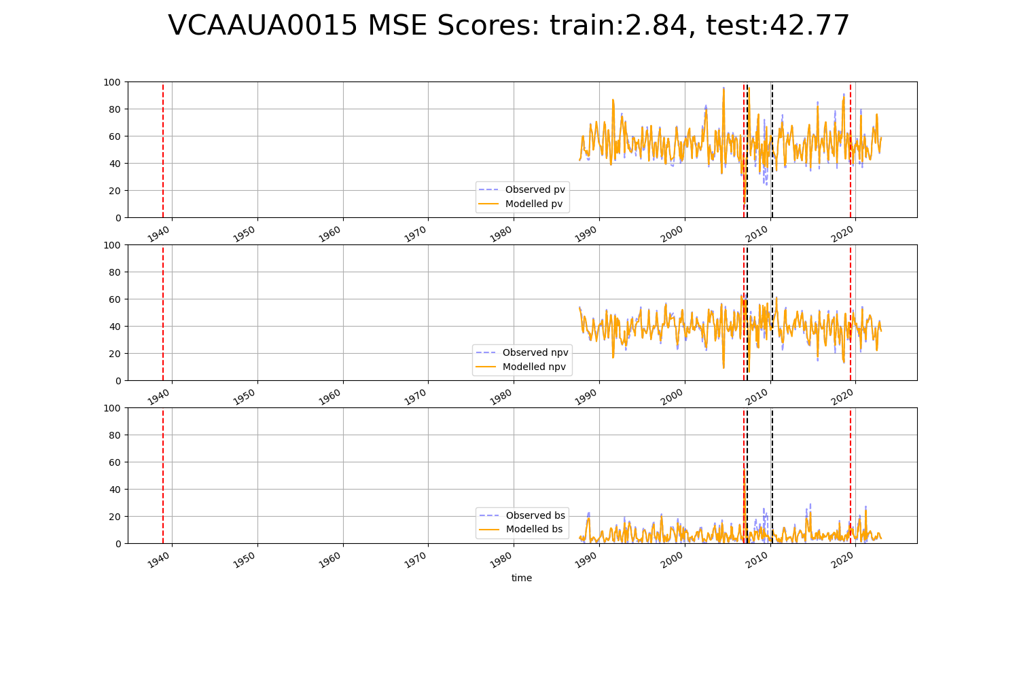

# WAAAVW0006

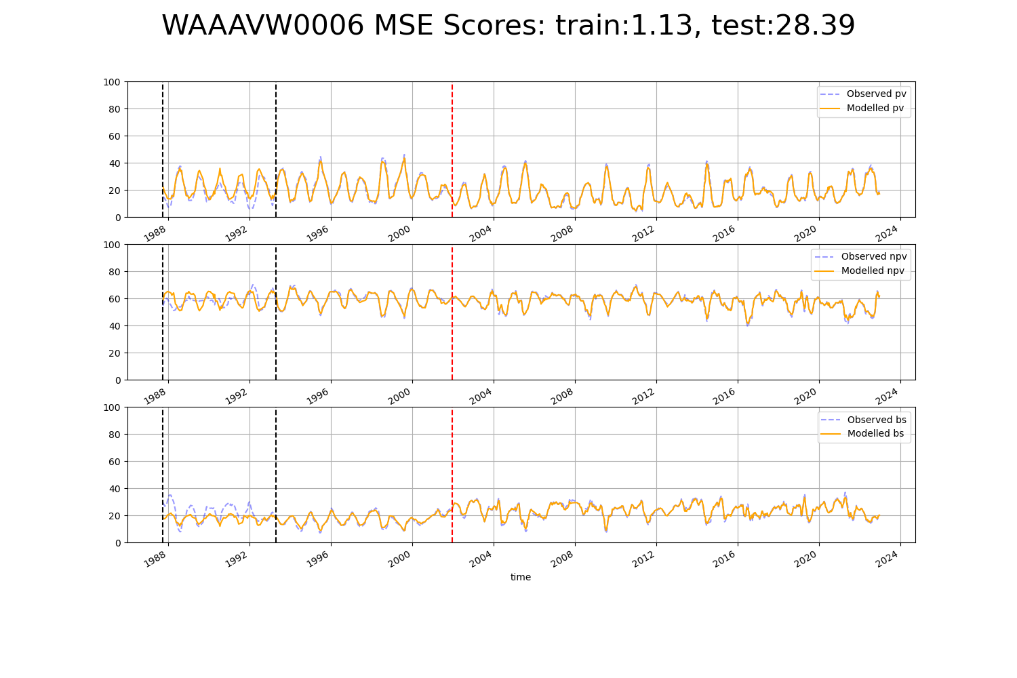

# WAACOO0005

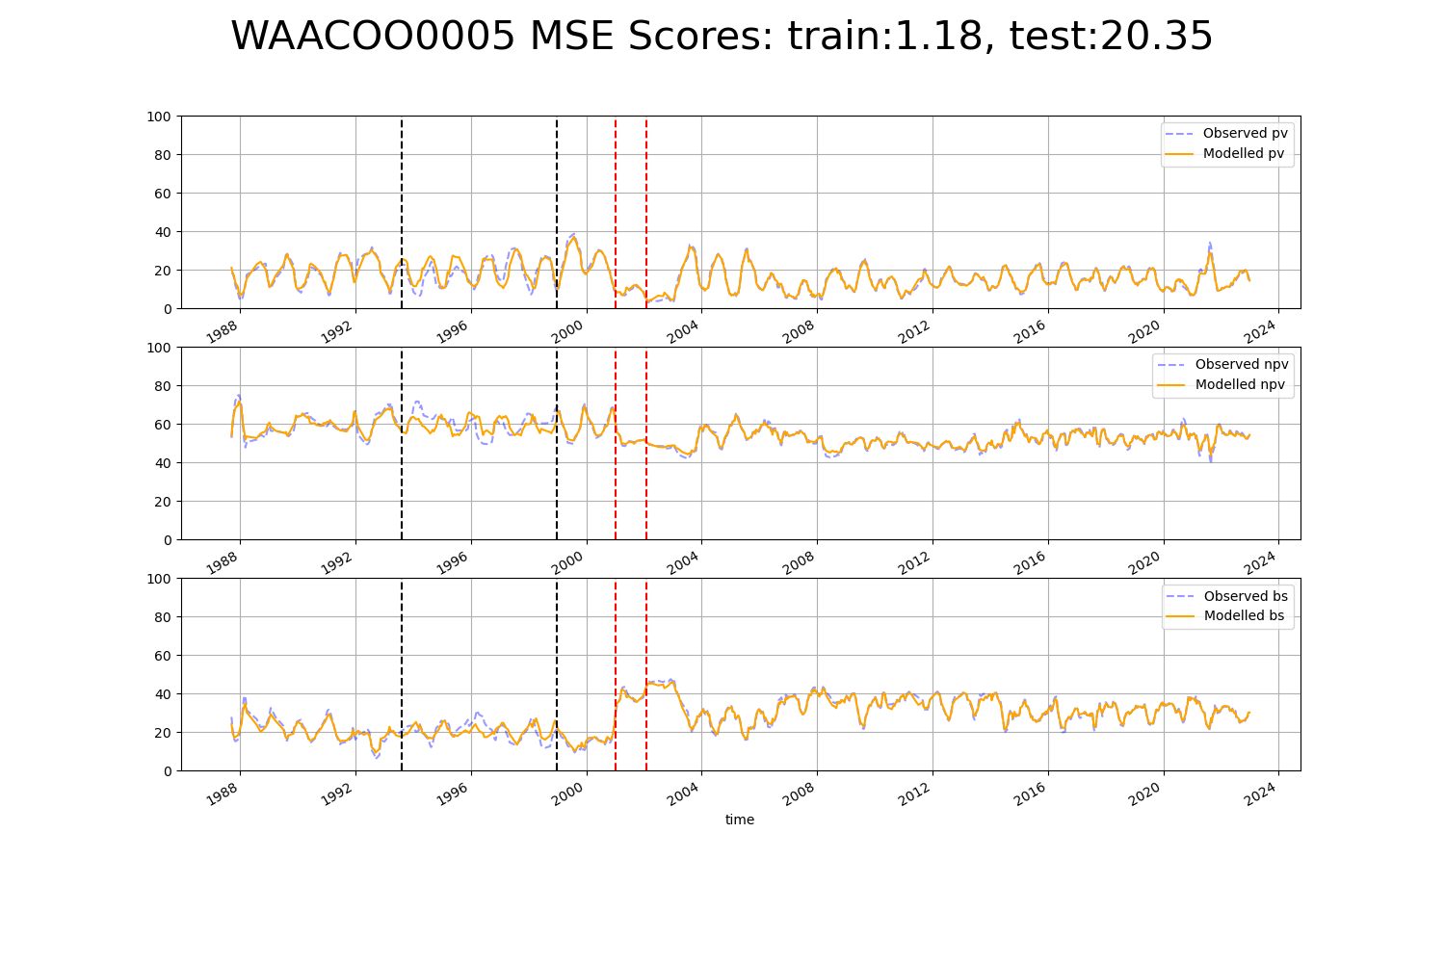

# WAACOO0019

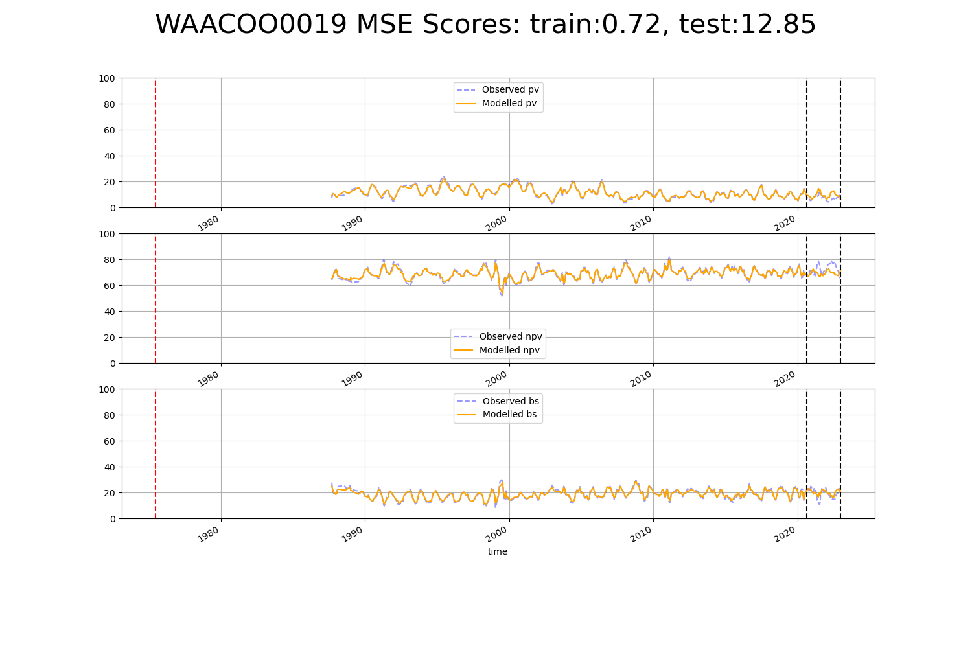

# WAASWA0003

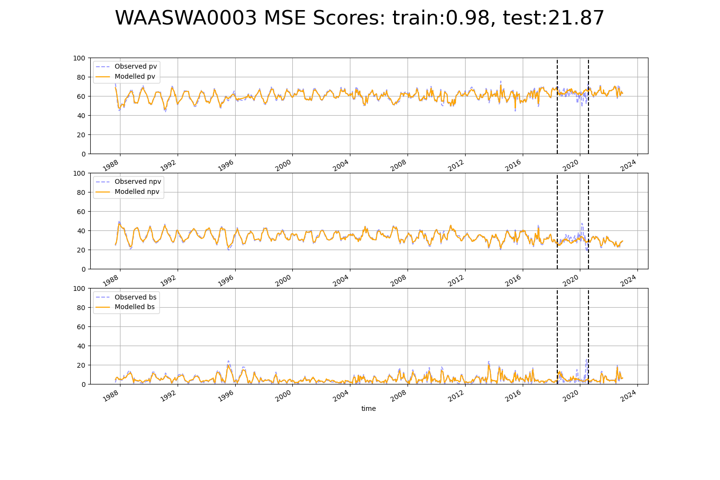

# WAAYAL0006

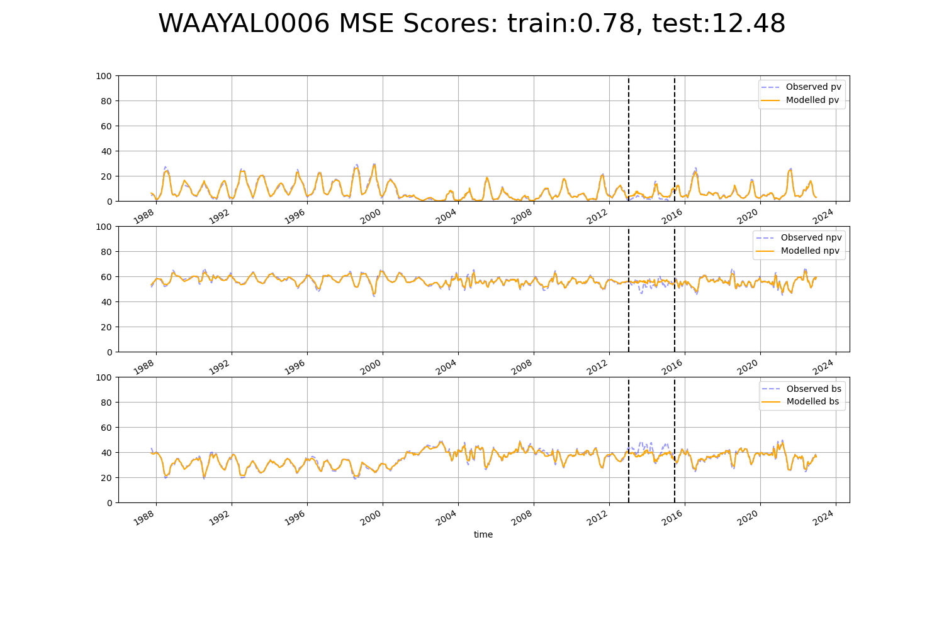

# WAAYAL0007

